**VIỆN ĐÀO TẠO QUỐC TẾ FPT**

**LẬP TRÌNH VIÊN QUỐC TẾ FPT – APTECH**

**Centre Name: ACE-HCMC-2-FPT.**

**Address: 590 Cach Mang Thang 8, District 3, Ho Chi Minh City, Viet Nam.**



**RGB Movie**

Design Document

|  |  |  |  |
| --- | --- | --- | --- |
| **Faculty:** | **Ngo Van Thuan** | | |
| **Batch No:** | T1.2112.E0 | | |
| **Group No:** | 05 | | |
| **Students:** |  | **Full Name** | **Roll No.** |
|  | 1. | Hua Le Quang | Student1350321 |
|  | 2. | Nguyen Tuan Loc | Student1350801 |
|  | 3. | Nguyen Phat Tai | Student1316806 |

## Table of Contents

**Table of Contents 2**

**Acknowledgements 6**

1. **Overview 8**
   1. Project Information 8
   2. Product Background 8
   3. Existing Systems 9
   4. Business Opportunity 9
   5. Project Scope & Limitations 10
2. **User Requirements 11**
   1. Actor 11
   2. High-level Use Case 12
   3. Use Case List 13
   4. Use Case & Actor mapping 15
3. **Management Plan 17**
   1. Scope and Estimation 17
   2. Management Approach 19
   3. Training Plan 20
4. **System Requirements 20**
   1. Hardware Requirement 20
   2. Software Requirements 20
   3. Technology Summary 21
5. **Architecture Design 24**
6. **Use Case and Sequence Diagram 25**
7. **Table Definition 65**
8. **Relational Schema**

**87**

1. **Web GUI Design**

**91**

1. **Mobile GUI Design 119**

## Acknowledgements

The satisfaction that accompanies the successful completion of any task would be incomplete without the mention of people whose ceaseless cooperation made it possible, whose constant guidance and encourage us to success.

We are grateful to our project guide Mr. Ngo Van Thuan for the guidance, inspiration, and constructive suggestions that helped us in the preparation of this project.

We also thank our colleagues who have helped in successful completion of the project.

# REVIEW1

## Overview

### Project Information

* + - Project name: RGB Movie
    - Group name: Group 05
    - Software type: Web Application, Mobile Application

### Product Background

Designing and developing a web and mobile application for cinema ticket booking involves several stages of production. Here's a brief overview of the production background:

Requirement gathering: This stage involves identifying the requirements of customer for the application. It is essential to gather feedback from users to determine the features and functionality that should be included in the application.

Design: Once the requirements are clear, the design phase begins. It includes creating the visual design of the application and defining the user interface and user experience. A prototype may be developed to get feedback from users.

Development: This phase involves the actual development of the application. The development team will use the appropriate technology stack to build the application, and the features identified in the design stage will be implemented.

Testing: Before the application is released, it must be thoroughly tested to ensure that it meets the requirements and functions as expected. Various types of testing, including functional, performance, and security testing, should be conducted.

Deployment: Once the application is tested and approved, it is deployed to the production environment. This involves setting up servers, configuring the database, and other technical tasks.

Maintenance and support: After the application is deployed, it is important to provide ongoing maintenance and support to ensure that it continues to function correctly. Bug fixes, updates, and improvements may be required over time.

To create a web project and mobile app for cinema ticket booking, it will need to consider the specific features and functionality that customer require. This can include booking movie tickets, keep up on now showing and coming soon movies, theaters, seats, view movies rating, post comments, ...

### Existing Systems

There are several existing systems for a cinema ticket booking web and mobile application projects that we can consider when developing your own app. Here are a few examples:

Fandango: One of the best movie ticketing app with over 2 million 5-Star Reviews. Available for all mobile users, browse Rotten Tomatoes® scores, and find the best showtimes and seats for more than 31,000 screens nationwide.

BookMyShow: Known as India’s No.1 all-in-one Entertainment portal, Over 60M+ Users have downloaded the BookMyShow app till Now. Through this app, you can book tickets for movies, sports, concerts and many other events happening in your city. You can also Check Movie Timings, Movie Reviews and Upcoming Movies.

Ticket New: Ticket New focuses on Booking Movie Tickets. The company has tie-up with Cinema Groups like Carnival, PVR, Movietime, Inox etc for booking tickets online. It is easy to use application and focus only on booking movie tickets which do not frustrate user with loads of other service popups.

CJ CGV: CJ CGV is the largest multiplex cinema chain in South Korea which also has branches in China, Indonesia, Myanmar, Turkey, Vietnam, and the United States. Their quality and diverse services, activities, events have become a bright model of the film industry.

Rotten Tomatoes®: Rotten Tomatoes and the Tomatometer score are the world’s most trusted recommendation resources for quality entertainment. As the leading online aggregator of movie and TV show reviews from critics, they provide fans with a comprehensive guide to what’s Fresh and what’s Rotten in theaters and at home.

When developing our own web and mobile application project, we can take inspiration from these existing systems and incorporate features and functionalities that are relevant to your target audience. It's important to conduct thorough research and identify the unique needs and pain points of your users to ensure that your application is successful.

### Business Opportunity

The cinema industry offers a variety of business opportunities. Here are some facts about business opportunities in the cinema industry:

Cinema ticket booking: Business cinema ticket booking can be very promising. You can build an online booking website, develop a mobile app or provide booking services for theaters.

Contests and Events: Organizing contest and recreational activities is an attractive business opportunity. You can create unique contests and activities, attracts sponsorship and building an enhancing platform where talented filmmakers can be identified.

Movies review: You can rate, share your watching experience and feeling about movies that you have watched.

A cinema ticket booking website and mobile app can bring many advantages in terms of attractive features for users. Below are some key points:

* Easy to use
* Quickly search and book cinema tickets
* View available and future movies, theater and seat details
* Wide range and frequent activities
* Convenient QR checking
* Online payment

### Project Scope & Limitations

A cinema ticket booking web project can require many complex elements and features to serve users in the best ways. However, here are some of the common limitations encountered in the project:

* Limited quality control: While a cinema ticket booking website may display reviews and comments from previous customers, it is difficult to control the actual quality of movies. This depends on the capabilities of the service and the individual customer experience.
* Theater or seat look and feel: Every theater may have different looks and designs. This may degrade the user experience or not satisfy some special requirements.
* Limited customer support: Some sites may not offer comprehensive customer support channels or slow response times.
* Payment feature limitations: A cinema ticket booking web project may struggle to integrate complex payment forms or support special payment processes.

## User Requirements

### Actor

|  |  |  |
| --- | --- | --- |
| **#** | **Actor** | **Description** |
| 0 | **Customer** | Normal users after successfully logging in can view movie, schedules, book and cancel booking. |
| 1 | **Admin** | The administrator have full control of the system. Responsible for adding and modify movies, theater, showtime, check booking history, block/unblock customer, etc. |
| 2 | **Staff** | Staff can login to the management console to check booking history and book/cancel booking. |

### High-level Use Case

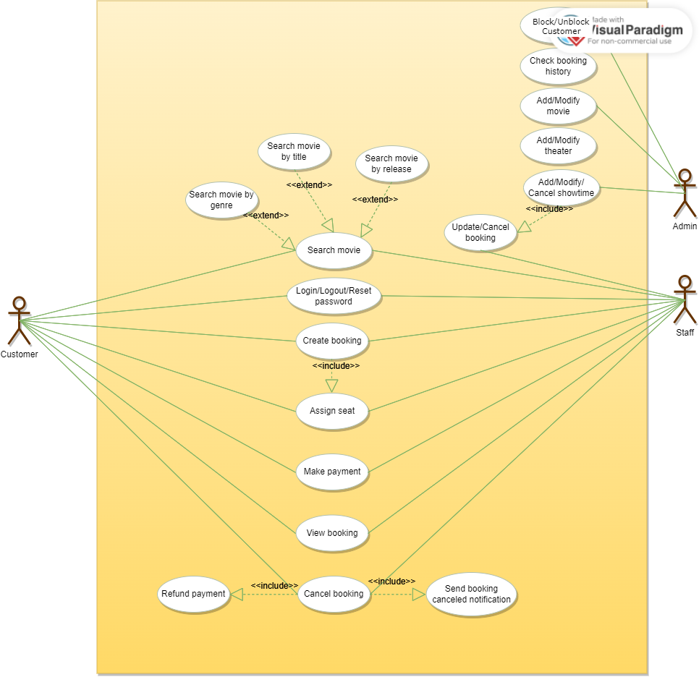

### Use Case List

|  |  |  |  |
| --- | --- | --- | --- |
| **#** | **Code** | **Name** | **Description** |
| **All users** | | | |
| 1 | UC101 | **Create account** | Create account with email and password or social identity provider (Google) |
| 2 | UC102 | **Login** | Login with email and password or social identity provider (Google) |
| 3 | UC103 | **Search And View All Theaters, Movies Details** | Search and view all available theaters, movies, upcoming movies information in details |
| **All logged in Users & Customer** | | | |
| 1 | UC107 | **Logout** | Logout from website or mobile app |
| 3 | UC109 | **Forgot password** | Reset current password |
| 4 | UC110 | **Book Movie Ticket** | Buy ticket for available movies |
| 5 | UC111 | **View Self Booking History, Status** | View ticket booking history |
| 6 | UC112 | **Edit, Cancel Self Booking** | Edit, Cancel booked ticket |
| **Admin** | | | |
| 1 | UC201 | **CRUD All Theaters, Movies, Screentime Details** | Can view/add/update/delete all Theaters, Movies and Showtime details |
| 3 | UC203 | **Disable Account** | Block account |
| 4 | UC204 | **View All Ticket Booking History, Status from Customer** | View all ticket booking history and status |
| 5 | UC205 | **Deny Ticket Booking** | Deny all ticket booking |
| **Staff** | | | |  | **Cancel Booking** |
| 1 | UC401 | **View Ticket Booking History, Status** | View his/her Theater ticket booking history and status |
| 2 | UC402 | **Book/Cancel Booking** | Book and cancel booking |

* 1. Use Case & Actor mapping

|  |  |  |  |  |
| --- | --- | --- | --- | --- |
| **Actor**  **Use Case** | | **Admin** | **Staff** | **Customer** |
| UC101 | **Create account** | x | x | x |
| UC102 | **Login** | x | x | x |
| UC103 | **Search And View All Theaters, Movies Details** | x | x | x |
| UC106 | **In-app Notification** | x | x | x |
| UC107 | **Logout** | x | x | x |
| UC108 | **Manage Self Profile** | x | x | x |
| UC109 | **Forgot password** | x | x | x |
| UC110 | **Book Movie Ticket** | x | x | x |
| UC111 | **Online Payment** | x | x | x |
| UC112 | **View Self Booking History, Status** | x | x | x |
| UC113 | **Cancel Booking** | x | x | x |
| UC201 | **Manage Theaters, Movies** | x |  |  |
| UC203 | **Block Account** | x |  |  |

|  |  |  |  |  |  |
| --- | --- | --- | --- | --- | --- |
| UC204  UC304 | **View Booking History, Status** | x | x | x | x |
| UC205  UC305 | **Deny Ticket Booking** | x | x |  |  |
| UC605 | **Management System** | x |  |  |  |

## Management Plan

The project started on 18 Oct and will be handed over on 22 Nov, so overall there will be ***5 weeks*** for planning, training, and implementation.

### Scope and Estimation

|  |  |  |  |  |
| --- | --- | --- | --- | --- |
| **#** | **WBS Item** | **Due Date** | **Complexity** | **Est. Effor (days)** |
| **1** | **Requirement and Planning** | | | **12** |
| 1.1 | Project Plan |  | Medium | 0.5 |
| 1.2 | Traning Plan |  | Medium | 0.5 |
| 1.3 | Review 1 - Introduction and Plan |  | Medium | 1 |
| 1.4 | Review 2 - System Design |  | Medium | 1 |
| 1.5 | Review 3 - Product Specification |  | Medium | 2 |
| 1.6 | Overall testing, system integration, documentations (user guide, installation guide) |  | Medium | 6 |
| 1.7 | Brief demo |  | Low | 1 |
| **2** | **Design** | | | **3** |
| 2.1 | Design User Interface (UI) prototypes |  | Medium | 2 |
| 2.2 | Overal System diagram |  | Low | 0.2 |

|  |  |  |  |  |
| --- | --- | --- | --- | --- |
| 2.3 | Write Use Case diagram |  | Medium | 0.2 |
| 2.4 | Draw Flow diagram |  | Medium | 0.2 |
| 2.5 | Entity Relation diagram (ERD) |  | Medium | 0.2 |
| 2.6 | Draw Class diagram |  | Medium | 0.2 |
| **3** | **Implementation** | | |  |
| **3.1** | **Database** | | | **1** |
| 3.1.1 | Implement database from the document (write SQL) |  | Low | 1 |
| **3.2** | **Authorization and Authentication** | | |  |
| 3.2.1 | Setup Authentication & Authorization for microservices (Auth0 integration) |  | High | 1 |
| 3.2.2 | Auth0 Login Page (for mobile app & web app) |  | High |  |
| 3.2.3 | Logout |  | High |  |
| 3.2.4 | Sign in/up hook |  | High |  |
| **3.3** | **API Service** | | |  |
| 3.3.1 | Setup monolith API repository |  | High |  |
| 3.3.2 | Config maven build/test/deploy lifecycle |  | Low |  |
| 3.3.3 | Setup Gitlab work |  | High |  |
| 3.3.4 | Account API(s) |  | High | 0.5 |
| 3.3.5 | Booking API(s) |  | Medium | 0.5 |
| 3.3.6 | Static Data API(s) |  | High | 0.5 |
| 3.3.7 | Staff API(s) |  | High | 0.5 |
| 3.3.8 | Schedule API(s) |  | Medium | 0.5 |
| 3.3.9 | Payment API(s) |  | Medium | 1 |
| 3.3.10 | Super Admin API(s) |  | Medium | 2 |

|  |  |  |  |  |
| --- | --- | --- | --- | --- |
| 3.3.13 | Email recover (using email provider like MailGun) |  | High | 1 |
| **3.4** | **Web App** | | |  |
| 3.4.1 | Register |  | High |  |
| 3.4.2 | Login |  | High |  |
| 3.4.3 | Home |  | High |  |
| 3.4.4 | Admin |  | High |  |
| 3.4.5 | Booking |  | Medium |  |
| 3.4.6 | Detail tour |  | Low |  |
| 3.4.7 | Language |  | High |  |
|  |  |  |  |  |
| **3.5** | **Mobile App** | | |  |
| 3.5.1 | Splash |  | High |  |
| 3.5.2 | Onboard-1 |  | High |  |
| 3.5.3 | Onboard-2 |  | High |  |
| 3.5.4 | Onboard-3 |  | High |  |
| 3.5.5 | Login |  | High |  |
| 3.5.6 | Forgot Password |  | High |  |
| 3.5.7 | Verify Password |  | High |  |
| 3.5.8 | Register |  | High |  |
| 3.5.9 | Terms of Service |  | High |  |
| 3.6.0 | Account |  | High |  |
| 3.6.1 | Home |  | High |  |

|  |  |  |  |  |
| --- | --- | --- | --- | --- |
| 3.6.2 | Not found |  | Low |  |
| 3.6.3 | Filter |  | Low |  |
| 3.6.4 | Explore |  | Low |  |
| 3.6.5 | Destination |  | Low |  |
| 3.6.6 | Policy |  | Low |  |
| 3.6.7 | Review |  | Low |  |
| 3.6.8 | Gallery |  | Low |  |
| 3.6.9 | Video |  | Low |  |
| 3.7.0 | Create Booking |  | Low |  |
| 3.7.1 | Note |  | Low |  |
| 3.7.2 | Payment |  | Low |  |
| 3.7.3 | Susccess |  | Low |  |
| 3.7.4 | Message |  | Low |  |
| 3.7.5 | Profile |  | Low |  |
| 3.7.6 | Edit |  | Low |  |
| 3.7.7 | Account and Setting |  | Low |  |

* 1. Management Approach

Applying the DevOps model to management enables the SPD team to implement the product with effective coordination among development team members.

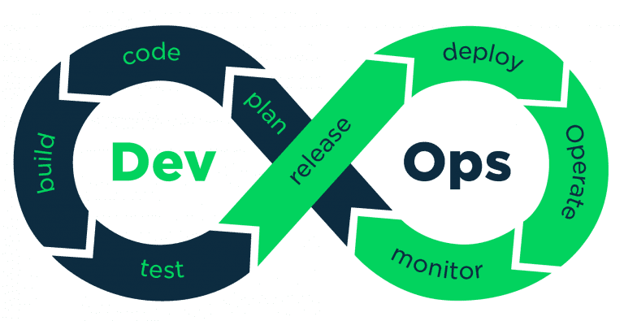

*DevOps lifecycle*

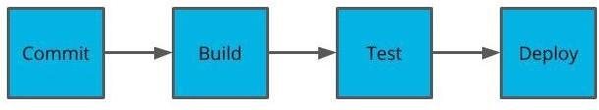

*Deployment pipeline*

* 1. Training Plan

|  |  |  |  |
| --- | --- | --- | --- |
| **Training Area** | **Participants** | **When, Duration** | **Waiver**  **Criteria** |
| Api for Spring Boot | All members | Week 1, 3 days | Mandatory |
| Github | All members | Week 1, 1-day | Mandatory |
| DrawIO | All members | Week 1, 1-day | Mandatory |
| Thymeleaf | All members | Week 2, 3 days | Mandatory |
| Dart, Flutter | All members | Week 2, 3 days | Mandatory |

## System Requirements

### Hardware Requirement

* AMD Opteron, AMD Athlon 64, Intel Xeon with Intel EM64T support, Intel Pentium IV with EM64T support or faster
* Processor Speed 2.0Ghz or faster
* 4G of RAM or higher. (8 GB recommended)
* Hard disk requirement: minimum 50GB
* Windows 10, or windows server 2016 or higher
* Snapdragon 2xx or higher
* Can connect to Internet

### Software Requirements

* Postgres database
* IntelliJ Community 2023 / Apache Netbeans 13 or 17
* Maven 3 CLI
* Java Development Kit (JDK) 17 or higher
* No web server requirement (Spring built-in Tomcat server)
* Visual Studio Code (with Dart + Flutter extension)
* Flutter SDK (stable version 3.x.x)
* Android / IOS virtual devices
* Spring Boot (3.x.x)
* Google Chrome, Opera, OperaGX

### Technology Summary

* Web Application: React
* Mobile Application: Flutter
* BackEnd APIs: Spring Boot
* Data Service: Amazon RDS MySql
* Deploy and Packaging: Docker, Azure Container

Task Sheet 1

|  |  |  |  |  |  |
| --- | --- | --- | --- | --- | --- |
| **Members Group** | | **Date Preparation of Activity Plan** | | | |
| **No** | **Name** | **Description Task** | **Start Date** | **End Date** | **Status** |
| 1 | All members | High-level use case | 18/10/2023 | 22/11/2023 | complete |
| User Case list | 18/10/2023 | 22/11/2023 | complete |
| Management Plan | 18/10/2023 | 22/11/2023 | complete |
| 2 | All members | Use Case & Actor  mapping | 18/10/2023 | 22/11/2023 | complete |
| 3 | Hua Le Quang | Product Overview | 18/10/2023 | 22/11/2023 | complete |
| Nguyen Tuan Loc | 18/10/2023 | 22/11/2023 | complete |
| 3 | Nguyen Phat Tai | System Requirements | 18/10/2023 | 22/11/2023 | complete |
|  | | | | | |
| **Teacher** | | | **Team Leader** | | |
| Ngo Van Thuan | | | Nguyen Tuan Loc | | |
|  | | |  | | |

# REVIEW 2

## Architecture Design

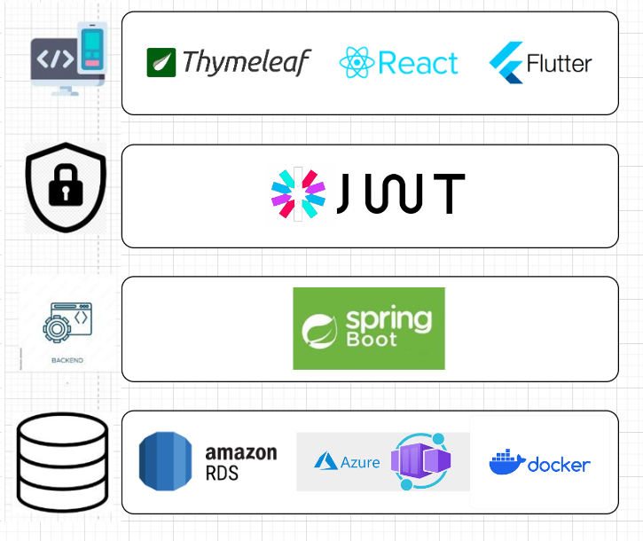

## Use Case and Sequence Diagram

### Login

|  |  |  |  |
| --- | --- | --- | --- |
| ID and Name: | UC101 - Login | | |
| Primary Actor: | Unauthorized user | Secondary Actor: | n/a |
| Description: | Anonymous user login into the system, and give access to specific features according to his/her role | | |
| Pre-condition: | Anonymous user | | |

|  |  |
| --- | --- |
| Post-condition: | **Success**: claim access token and will be redirected to home Unauthorized userpage  **Fail**: the system show error message |
| Normal Flow: | **Web application:**   1. Anonymous user try to access restricted resource 2. He/she will be redirected to Login Page 3. User fill in the login form:    * Email: text input    * Password: password input 4. User clicks on “Login” button 5. Authorization server validates given credentials and response access token 6. The browser immediately redirects the user to Home Page 7. Home Page shows up specific features based on the user’s role   **Mobile application:**   1. Anonymous user opens Pulse mobile application 2. Login Screen will show up 3. User fill in the login form:    * Email: text input    * Password: password input 4. User clicks on “Login” button 5. Authorization server validates given credentials and response access token 6. Mobile app redirects user to Home Screen |
| Alternative Flow: | *n/a* |
| Exception Flow: | **Anonymous user fails to fill in all the required fields**   * Frontend shows messages MSG08   **Anonymous user provides incorrect credentials**   * Frontend shows message MSG04.   **Internet connection lost**   * Frontend forwards to Lost Internet page. |
| Priority: | High |
| Frequency of Usage: | Sometimes |

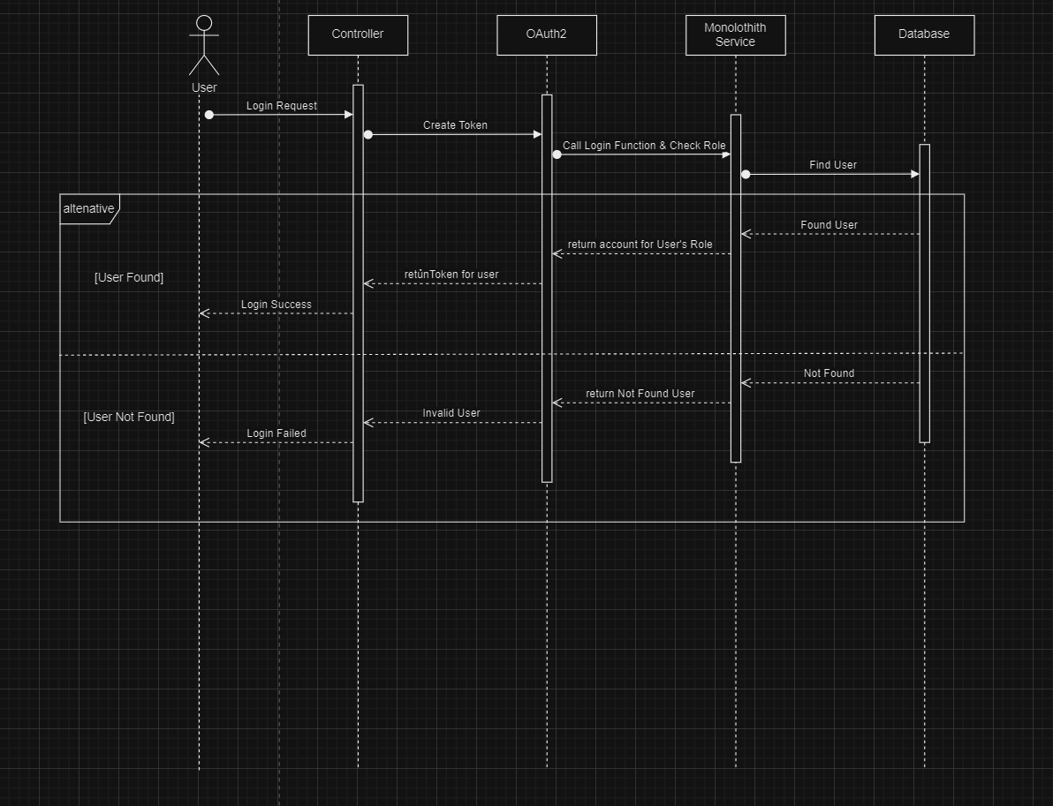

* 1. Logout

|  |  |  |  |
| --- | --- | --- | --- |
| ID and Name: | UC102 - Logout | | |
| Primary Actor: | Authenticated user | Secondary Actor: | n/a |
| Description: | User leaves the system and clears all access token in the browser. The system will require the user to log in again. | | |
| Pre-condition: | User successfully logged in | | |
| Post-condition: | User logged out, require to login again to access restricted resources | | |

|  |  |
| --- | --- |
| Normal Flow: | **Web application:**   1. User click on “Logout” button on the menu-bar 2. User will be redirect back to Login Page   **Mobile application:**   1. User taps on “Profile” icon at the bottom 2. Sidebar shows up 3. User taps on “Logout” button 4. User will be redirect back to Login Screen |
| Alternative Flow: | *n/a* |
| Exception Flow: | *n/a* |
| Priority: | High |
| Frequency of Usage: | sometimes |

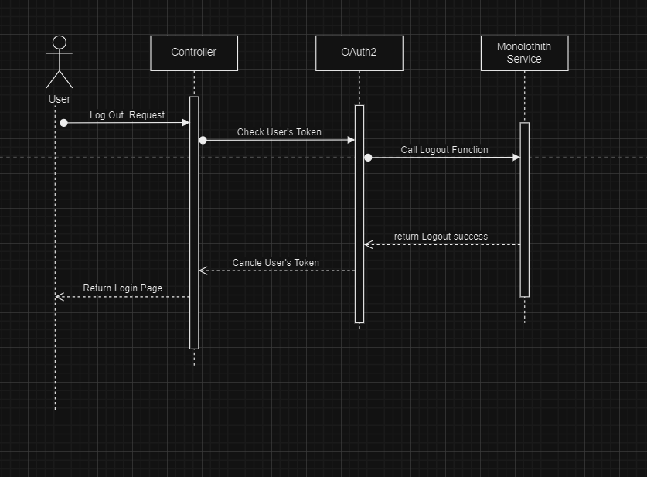

### Change Password

|  |  |  |  |
| --- | --- | --- | --- |
| ID and Name: | UC103 - Change Password | | |
| Primary Actor: | Authenticated user | Secondary Actor: | n/a |
| Description: | User retype the old password and provide a new password for future authentication. | | |
| Pre-condition: | User successfully logged in | | |
| Post-condition: | User must use the new password to log in | | |
| Normal Flow: | **Web & Mobile application:**   1. User goes to Profile Page/Screen 2. User clicks/taps on “Change Password” button 3. Change Password form will show up 4. User fills in the form:    * New password: password input    * Confirm password: password input 5. User clicks/taps on “Submit” button 6. Pulse system response with a success status code 7. User will be navigated back to Profile Page/Screen | | |
| Alternative Flow: | *n/a* | | |
| Exception Flow: | **User didn’t provide enough required information**   * Frontend shows messages MSG08   **User provides an invalid confirm password**   * Frontend shows message MSG07. | | |
| Priority: | Medium | | |
| Frequency of Usage: | sometimes | | |

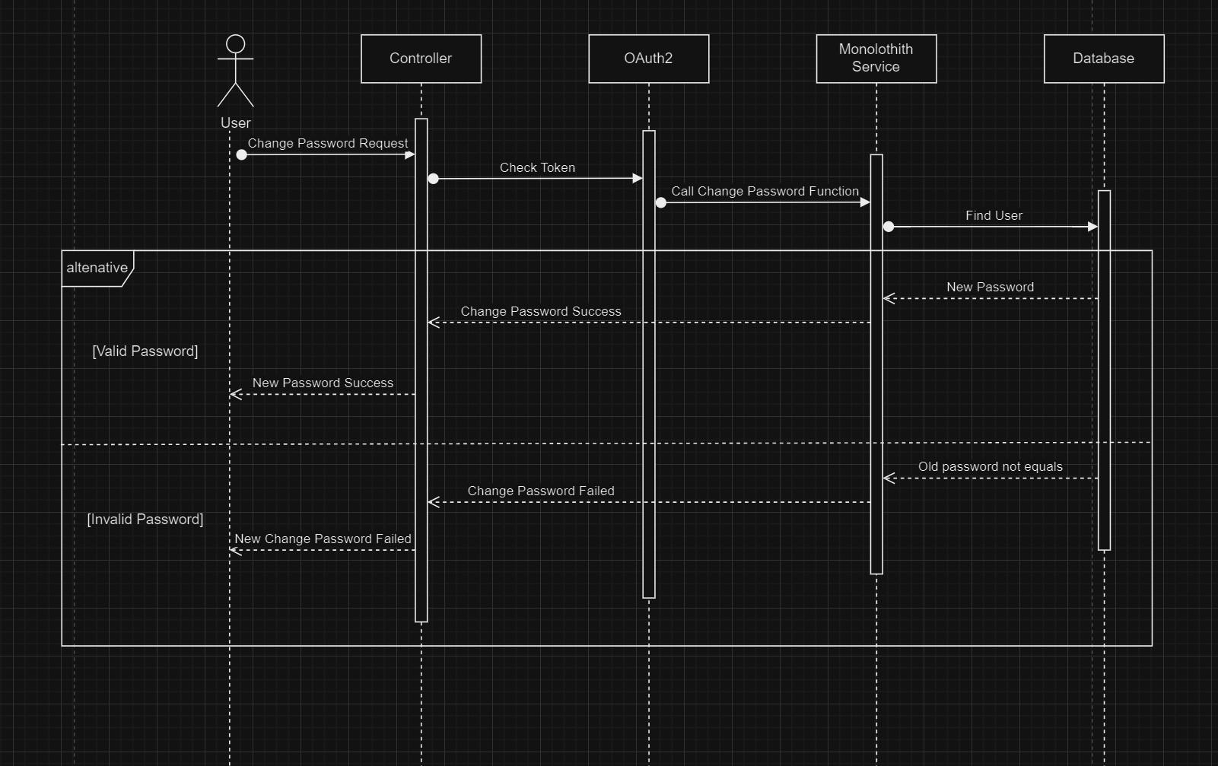

* 1. Forgot Password

|  |  |  |  |
| --- | --- | --- | --- |
| ID and Name: | UC104 - Forgot Password | | |
| Primary Actor: | Anonymous user | Secondary Actor: | n/a |
| Description: | Anonymous user request for reset password, and follow a reset password URL to provide new password | | |
| Pre-condition: | User is not logged in. User has an account it Pulse system. User is able to access the mailbox of the account’s email address. | | |
| Post-condition: | User must log in with the new password | | |
| Normal Flow: | **Web & Mobile application:**   1. Anonymous user goes to Login Page/Screen 2. He/she clicks/taps on “Forgot Password” link 3. Forgot Password Page shows up 4. User fills in the form:    * Email: input text 5. User clicks/taps on “Send Reset Password Mail” button 6. User receives a reset password mail in mailbox 7. User clicks/taps on the link 8. Reset Password Page shows up | | |

|  |  |
| --- | --- |
|  | 1. User fills in the form:    * New password: password input    * Confirm password: password input 2. User clicks/tabs on “Submit” button 3. User will be redirected to Login Page/Screen |
| Alternative Flow: | *n/a* |
| Exception Flow: | **User didn’t provide enough required information**   * Frontend shows messages MSG08   **User provides invalid confirm password**   * Frontend shows message MSG07.   **User clicks on expired reset password URL**   * Frontend shows message MSG05. |
| Priority: | Medium |
| Frequency of Usage: | sometimes |

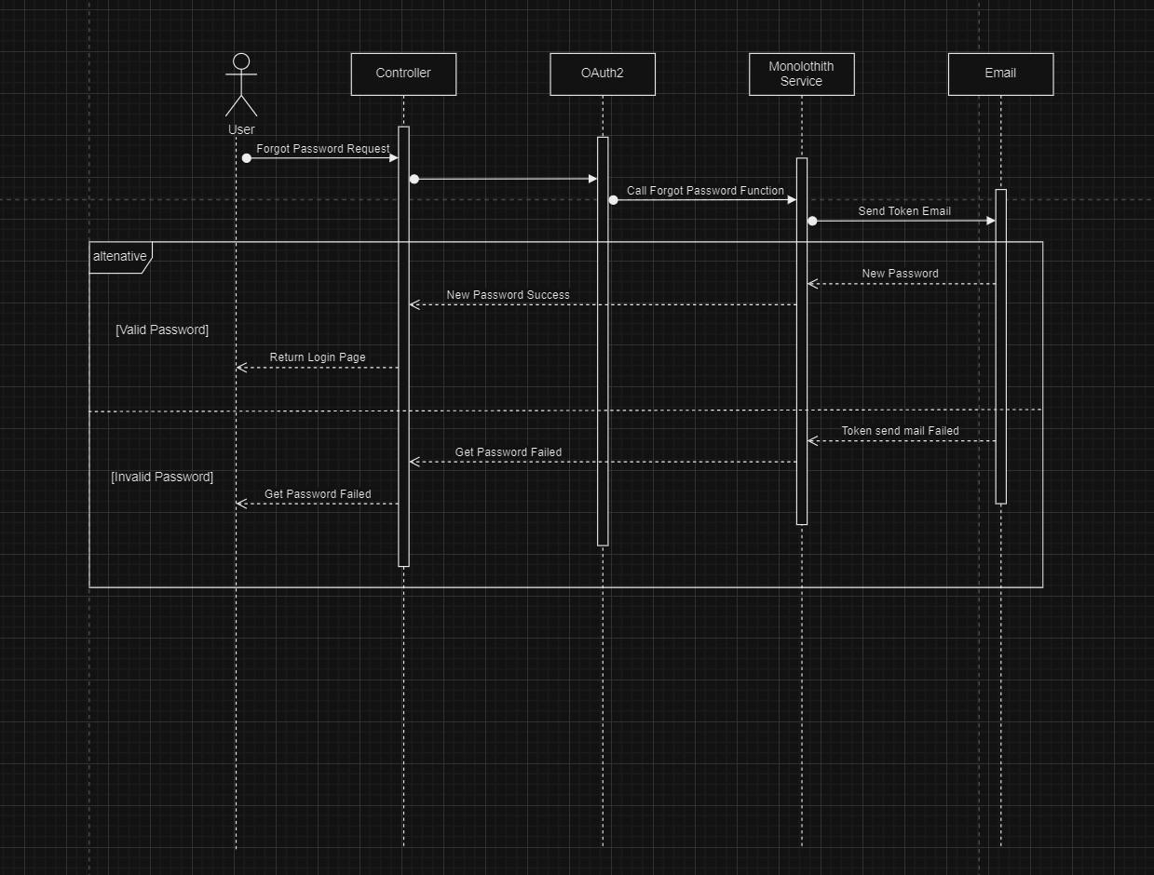

### Sign Up

|  |  |  |  |
| --- | --- | --- | --- |
| ID and Name: | UC111 - Sign Up | | |
| Primary Actor: | Anonymous user | Secondary Actor: | n/a |
| Description: | Anonymous user register new account | | |
| Pre-condition: | User is not logged in. User has an account in system. User is able to access the mailbox of the account’s email address. | | |
| Post-condition: | User is able to login into mobile app | | |
| Normal Flow: | **Mobile application:**  1. Anonymous user opens mobile application | | |

|  |  |
| --- | --- |
|  | 1. Login Screen will show up 2. User tap on “Sign Up” button 3. User fill in the registration form:    * Email: text input    * Password: password input    * Confirm Password: password input 4. User clicks on “Submit” button 5. Authorization server validates given credentials and send welcome email 6. Mobile app redirects user to Login Screen |
| Alternative Flow: | n/a |
| Exception Flow: | **User didn’t provide enough required information**   * Frontend shows messages MSG08   **User provides invalid information**   * Frontend shows message MSG07. |
| Priority: | Medium |
| Frequency of Usage: | Sometime |

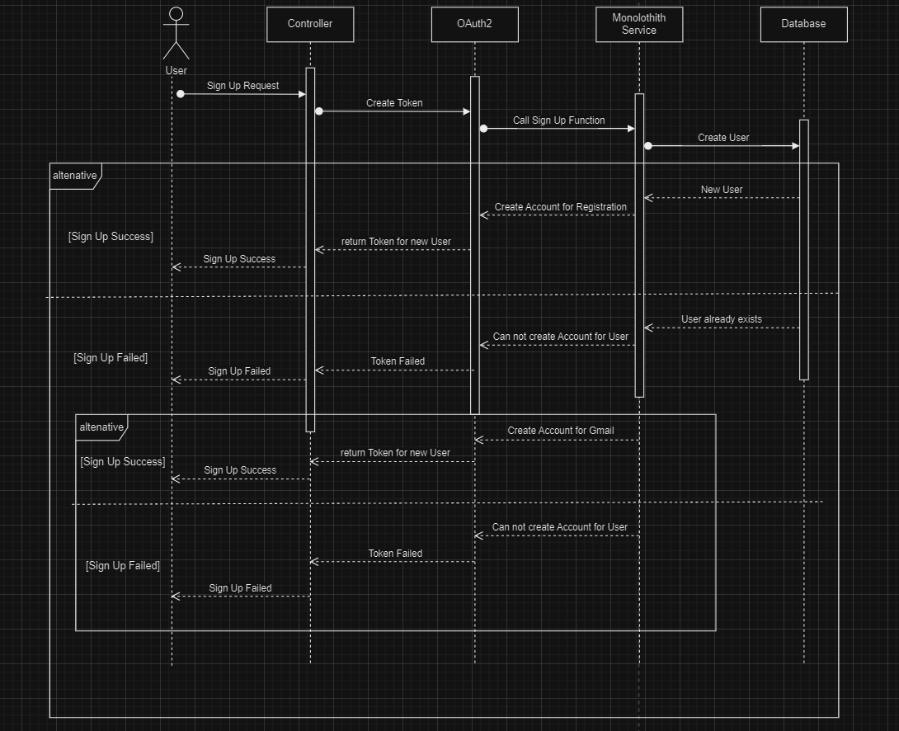

* 1. View Profile

|  |  |  |  |
| --- | --- | --- | --- |
| ID and Name: | UC107 - View Profile | | |
| Primary Actor: | Authenticated User | Secondary Actor: | n/a |
| Description: | Patient (or normal user) view his/her basic information on mobile app | | |
| Pre-condition: | User successfully logged in | | |
| Post-condition: | Detail personal information will be displayed | | |
| Normal Flow: | **Mobile application:**   1. User tap on “Profile” button on bottom right | | |

|  |  |
| --- | --- |
|  | 2. Display current personal information |
| Alternative Flow: | *n/a* |
| Exception Flow: | *n/a* |
| Priority: | Medium |
| Frequency of Usage: | Sometimes |

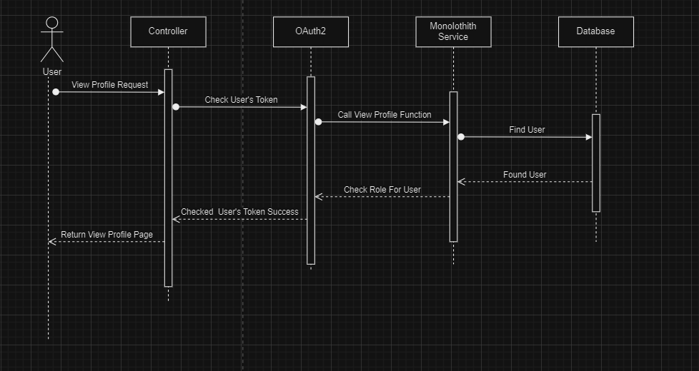

2.7 List Customer

|  |  |  |  |
| --- | --- | --- | --- |
| ID and Name: | UC601 - List Customer | | |
| Primary Actor: | Authenticated user | Secondary Actor: | n/a |
| Description: | Admin/Staff views a list of Customer. | | |
| Pre-condition: | Authenticated user with role Admin and Staff | | |
| Post-condition: | **Success**: UI shows a list of Customer.  **Fail**: UI popup an error message (e.g. access denied). | | |
| Normal Flow: | **Web & Mobile application:**   1. User clicks/taps “Customers” tab in left sidebar 2. The Customer page shows up, and the browser requests to get the Customer list. 3. Admin can active/inactive customer 4. This page contains a table, information include:    * Name: text    * Email: text 5. User can click/tap on a row to see detail information (a row will expand) | | |
| Alternative Flow: | *n/a* | | |
| Exception Flow: | **Internet connection lost**   * Frontend forwards to Lost Internet page. | | |
| Priority: | High | | |
| Frequency of Usage: | Often | | |

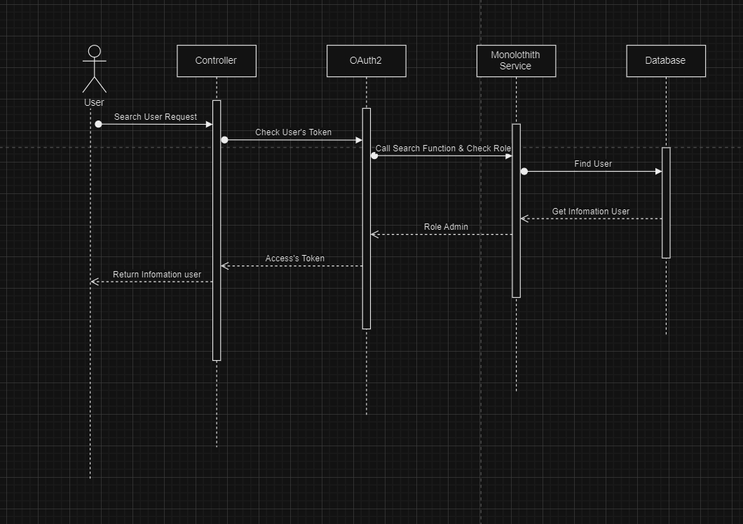

### Book Ticket

|  |  |  |  |
| --- | --- | --- | --- |
| ID and Name: | UC501 - Booking | | |
| Primary Actor: | Authenticated User | Secondary Actor: | n/a |
| Description: | Customer or Staff add new event | | |
| Pre-condition: | Authenticated user with role Customer and Staff | | |
| Post-condition: | New booking added | | |
| Normal Flow: | **Web application:**  1. User clicks “Book” tab | | |

|  |  |
| --- | --- |
|  | 1. The movie page shows up. 2. User choose date, theater, seat 3. Payment 4. New booking added |
| Alternative Flow: | *n/a* |
| Exception Flow: | **Admin didn’t provide enough required information**   * Frontend shows messages MSG08   **Admin provides invalid information (e.g. invalid format)**   * Frontend shows message MSG07. |
| Priority: | High |
| Frequency of Usage: | Often |

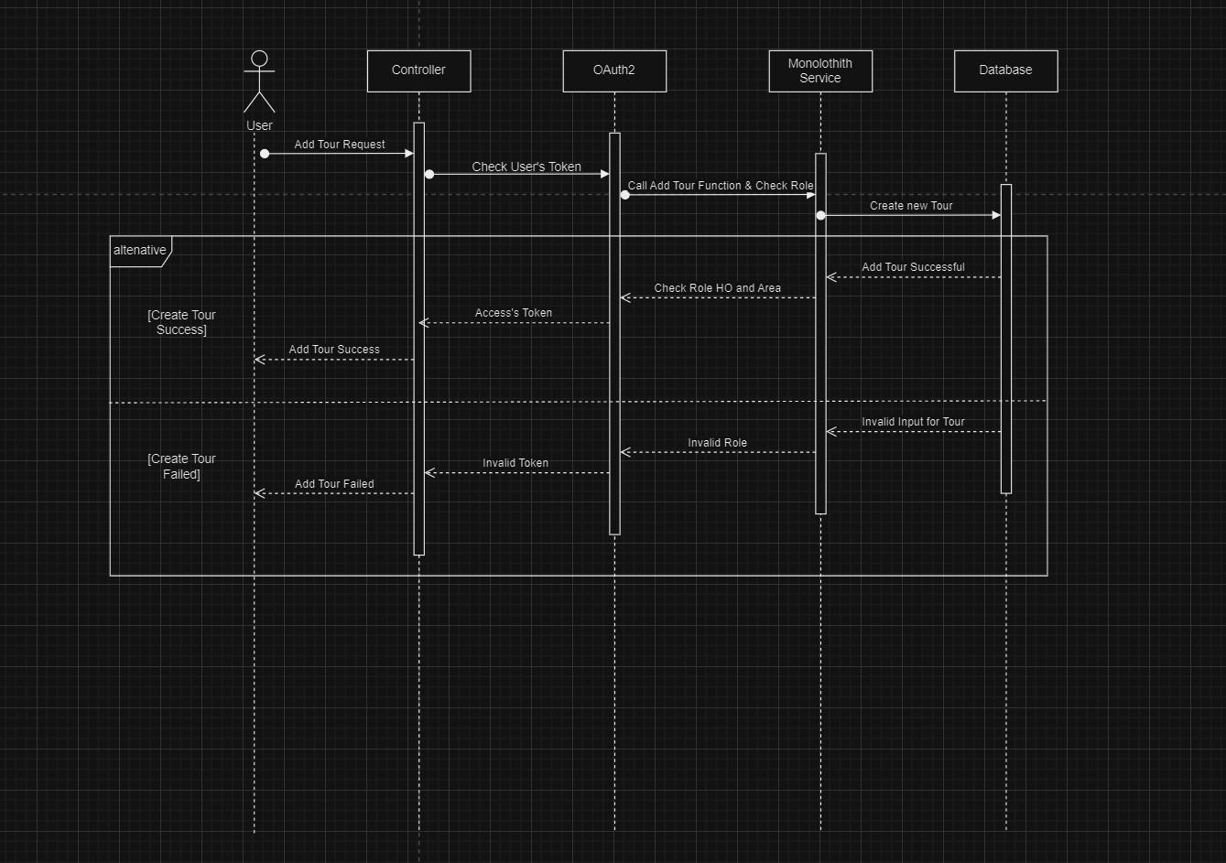

## Table Definition

### Auditorium

|  |  |  |  |  |  |  |
| --- | --- | --- | --- | --- | --- | --- |
| **Key** | **Field Name** | **Data Type** | **Allow Null** | **Default Value** | **Reference Table** | **Description** |
| PK | pk | Int | No | - | - | Auto_Increment |
|  | au_name | String | No | - | - |  |
|  | au_rows | Int | No | - | - |  |
|  | au_columns | Int | No | - | - |  |
| FK | theater | Int | No |  |  |  |

**Constraints:**

|  |  |  |
| --- | --- | --- |
| **Name** | **Field Name** | **Type** |
| FK_Auditorium_theater_Theater_pk | theater | Unique, Non-Clustered |

### Banking

|  |  |  |  |  |  |  |
| --- | --- | --- | --- | --- | --- | --- |
| **Key** | **Field Name** | **Data Type** | **Allow Null** | **Default Value** | **Reference Table** | **Description** |
| PK | pk | Int | No | - | - |  |
|  | time | Datetime | Yes | Current_timestamp | - |  |
| FK | reservation_id | Int | Yes | - | - |  |
| FK | user_id | Int | Yes | - | - |  |

**Constraints:**

|  |  |  |
| --- | --- | --- |
| **Name** | **Field Name** | **Type** |
| fk_banking_res | reservation_id | Unique, Non-Clustered |
| fk_banking_user | user_id | Unique, Non-Clustered |

### Cast

|  |  |  |  |  |  |  |
| --- | --- | --- | --- | --- | --- | --- |
| **Key** | **Field Name** | **Data Type** | **Allow Null** | **Default Value** | **Reference Table** | **Description** |
| PK | pk | Int | No | - | - | Auto_increment |
|  | actor | String | Yes | - | - |  |
|  | eng_actor | String | Yes | - | - |  |
|  | profile_img | String | Yes | - | - |  |

### Casting

|  |  |  |  |  |  |  |
| --- | --- | --- | --- | --- | --- | --- |
| **Key** | **Field Name** | **Data Type** | **Allow Null** | **Default Value** | **Reference Table** | **Description** |
| PK | pk | Int | No | - | - | Auto_increment |
| FK | movie | Int | Yes | - | - |  |
|  | actor | Int | Yes | - | - |  |
| FK | cast | String | Yes | - | - |  |

**Constraints:**

|  |  |  |
| --- | --- | --- |
| **Name** | **Field Name** | **Type** |
| FK_Casting_actor_Cast_pk | cast | Unique, Non-Clustered |
| FK_Casting_movie_Movie_pk | movie | Unique, Non-Clustered |

### Directing

|  |  |  |  |  |  |  |
| --- | --- | --- | --- | --- | --- | --- |
| **Key** | **Field Name** | **Data Type** | **Allow Null** | **Default Value** | **Reference Table** | **Description** |
| PK | pk | Int | No | - | - | Auto_increment |
| FK | movie | Int | Yes | - | - |  |
| FK | director | Int | Yes | - | - |  |

**Constraints:**

|  |  |  |
| --- | --- | --- |
| **Name** | **Field Name** | **Type** |
| FK_Directing_movie_Movie_pk | movie | Unique, Non-Clustered |
| FK_Directing_director_Director_pk | director | Unique, Non-Clustered |

### Director

|  |  |  |  |  |  |  |
| --- | --- | --- | --- | --- | --- | --- |
| **Key** | **Field Name** | **Data Type** | **Allow Null** | **Default Value** | **Reference Table** | **Description** |
| PK | pk | Int | No | - | - | Auto_increment |
|  | director | String | Yes | - | - |  |
|  | eng_director | String | Yes | - | - |  |
|  | profile_img | String | Yes | - | - |  |

* 1. Eventcontainer

|  |  |  |  |  |  |  |
| --- | --- | --- | --- | --- | --- | --- |
| **Key** | **Field Name** | **Data Type** | **Allow Null** | **Default Value** | **Reference Table** | **Description** |
| PK | pk | Int | No | - | - | Auto_increment |
|  | event_name | String | Yes | - | - |  |
|  | container_img | String | Yes | - | - |  |
|  | container_link | Text | No | - | - |  |
|  | is_active | Int | Yes | - | - |  |

### Maincontainer

|  |  |  |  |  |  |  |
| --- | --- | --- | --- | --- | --- | --- |
| **Key** | **Field Name** | **Data Type** | **Allow Null** | **Default Value** | **Reference Table** | **Description** |
| PK | pk | Int | No | - | - | Auto_increment |
|  | Event_name | String | Yes | - | - |  |
|  | Posting_start | Datetime | Yes | - | - |  |
|  | Posting_end | Datetime | Yes | - | - |  |
|  | Container_img | String | Yes | - | - |  |
|  | Container_link | Text | No | - | - |  |
|  | Is_active | Bit | Yes | - | - |  |

### Screening

|  |  |  |  |  |  |  |
| --- | --- | --- | --- | --- | --- | --- |
| **Key** | **Field Name** | **Data Type** | **Allow Null** | **Default Value** | **Reference Table** | **Description** |
| PK | pk | Int | No | - | - |  |
| Fk | Movie | Int | No | - | - |  |
| Fk | Theater | Int | No | - | - |  |
| Fk | Auditorium | Int | No | - | - |  |
|  | Time | Datetime | No | - | - |  |

**Constraints:**

|  |  |  |
| --- | --- | --- |
| **Name** | **Field Name** | **Type** |
| FK_Screening_movie_Movie_pk | movie | Unique, Non-Clustered |
| FK_Screening_theater_Theater_pk | theater | Unique, Non-Clustered |
| FK_Screening_ auditorium_Auditorium_pk | auditorium | Unique, Non-Clustered |

### Seat

|  |  |  |  |  |  |  |
| --- | --- | --- | --- | --- | --- | --- |
| 1. **Key** | **Field Name** | **Data Type** | **Allow Null** | **Default Value** | **Reference Table** | **Description** |
| PK | pk | Int | No | - | - |  |
| Fk | Auditorium | Int | Yes | - | - |  |
|  | Seat_name | String | Yes | - | - |  |

**Constraints:**

|  |  |  |
| --- | --- | --- |
| **Name** | **Field Name** | **Type** |
| FK_Seat_auditorium_Auditorium_pk | auditorium | Unique, Non-Clustered |

### Payment

|  |  |  |  |  |  |  |
| --- | --- | --- | --- | --- | --- | --- |
| 1. **Key** | **Field Name** | **Data Type** | **Allow Null** | **Default Value** | **Reference Table** | **Description** |
| PK | Pk | Int | No | - | - |  |
|  | Name | String | Yes | - | - |  |
|  | Card_number | Int | Yes | - | - |  |
|  | Date_expired | String | Yes | - | - |  |
|  | Cvv | String | Yes | - | - |  |
| FK | User_id | int | Yes | - | - |  |

**Constraints:**

|  |  |  |
| --- | --- | --- |
| **Name** | **Field Name** | **Type** |
| fk_payment_user | User_id | Unique, Non-Clustered |

### Passwordresettoken

|  |  |  |  |  |  |  |
| --- | --- | --- | --- | --- | --- | --- |
| 1. **Key** | **Field Name** | **Data Type** | **Allow Null** | **Default Value** | **Reference Table** | **Description** |
| PK | Pk | Int | No | - | - |  |
|  | token | String | NO | - | - |  |
|  | expiryDate | Datetime | No | - | - |  |
| FK | User_id | int | No | - | - |  |

**Constraints:**

|  |  |  |
| --- | --- | --- |
| **Name** | **Field Name** | **Type** |
| pst_user | User_id | Unique, Non-Clustered |

### Theater

|  |  |  |  |  |  |  |
| --- | --- | --- | --- | --- | --- | --- |
| **Key** | **Field Name** | **Data Type** | **Allow Null** | **Default Value** | **Reference Table** | **Description** |
| PK | pk | Int | No | - | - |  |
|  | Location | String | Yes | - | - |  |
|  | Sub_location | String | Yes | - | - |  |
|  | Address | String | Yes | - | - |  |

### User

|  |  |  |  |  |  |  |
| --- | --- | --- | --- | --- | --- | --- |
| **Key** | **Field Name** | **Data Type** | **Allow Null** | **Default Value** | **Reference Table** | **Description** |
| PK | Pk | Int | Yes | - | - |  |

|  |  |  |  |  |  |  |
| --- | --- | --- | --- | --- | --- | --- |
|  | Username | String | No | - | - |  |
|  | Password | String | No | - | - |  |
|  | Last_name | String | No | - | - |  |
|  | First_name | String | No | - | - |  |
|  | Email | String | No | - | - |  |
|  | Phone_number | String | No | - | - |  |
|  | Images | String | Yes | - | - |  |
|  | Enable | Bit | No | - | - |  |

1. **Relational Schema**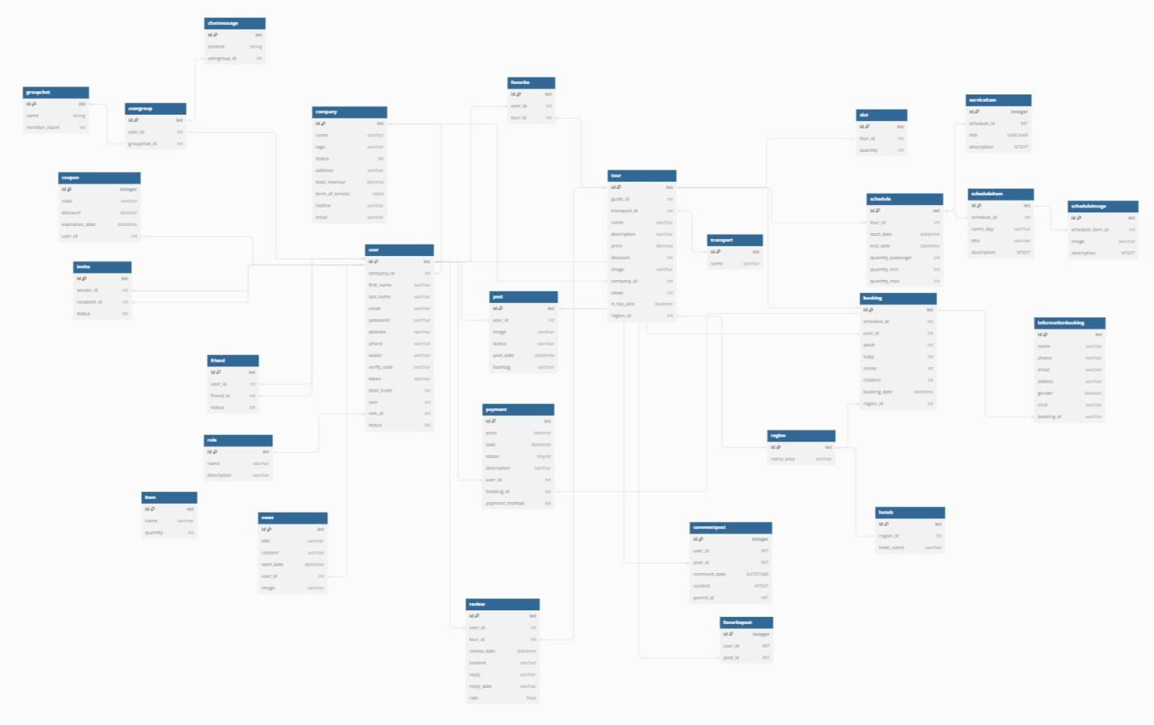

Task Sheet 2

|  |  |  |  |  |  |
| --- | --- | --- | --- | --- | --- |
| **Members Group** | | **Date Preparation of Activity Plan** | | | |
| **No** | **Name** | **Description Task** | **Start Date** | **End Date** | **Status** |
| 1 | All Members | Architecture Design | 18/10/2023 | 22/11/2023 | completed |
| Use Case & Sequence Diagram | 18/10/2023 | 22/11/2023 | completed |
| Class Diagram | 18/10/2023 | 22/11/2023 | completed |
| Table Definition | 18/10/2023 | 22/11/2023 | completed |
| 2 | Hua Le Quang | Use Case & Sequence Diagram | 18/10/2023 | 22/11/2023 | completed |
| 3 | Nguyen Phat Tai | 18/10/2023 | 22/11/2023 | completed |
| 4 | Nguyen Tuan Loc | Relational Schema | 18/10/2023 | 22/11/2023 | completed |
|  | | | | | |
| **Teacher** | | | **Team Leader** | | |
| Ngo Van Thuan | | | Nguyen Tuan Loc | | |
|  | | |  | | |

# REVIEW 3

## Dashboard

### Admin Login

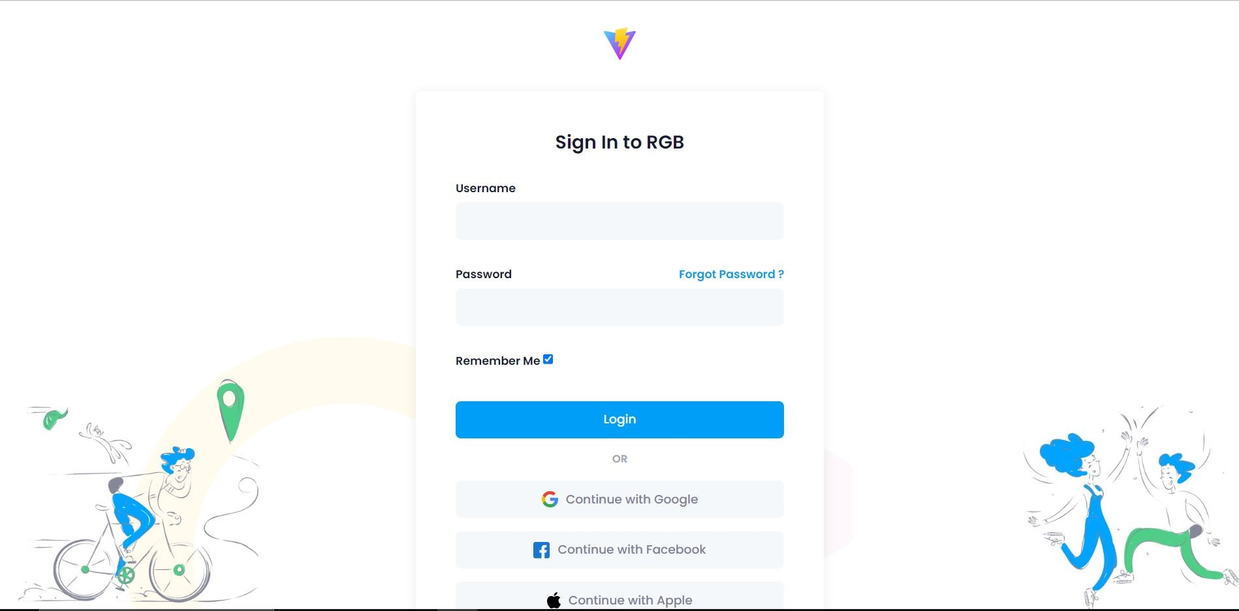

### Auditorium

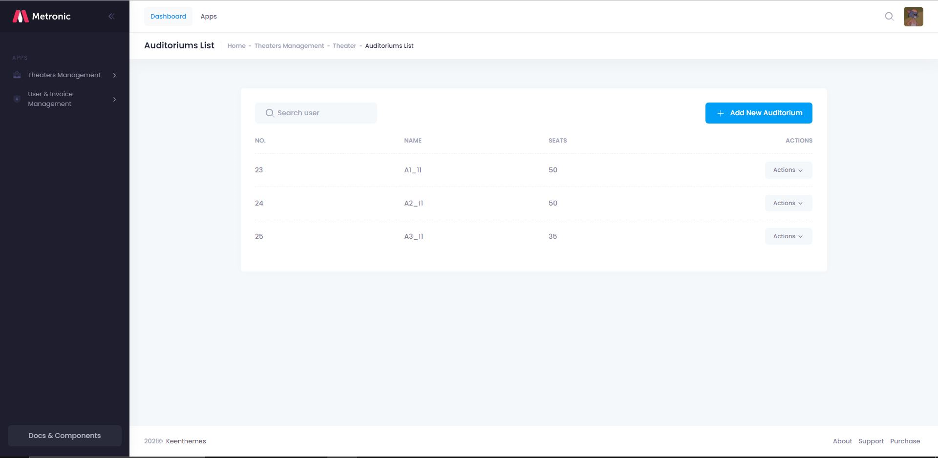

### Auditorium details

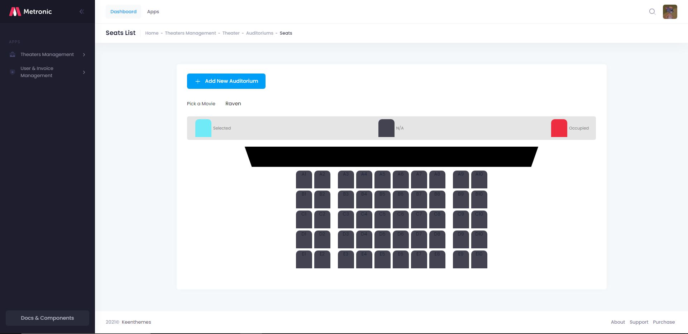

### Admin details

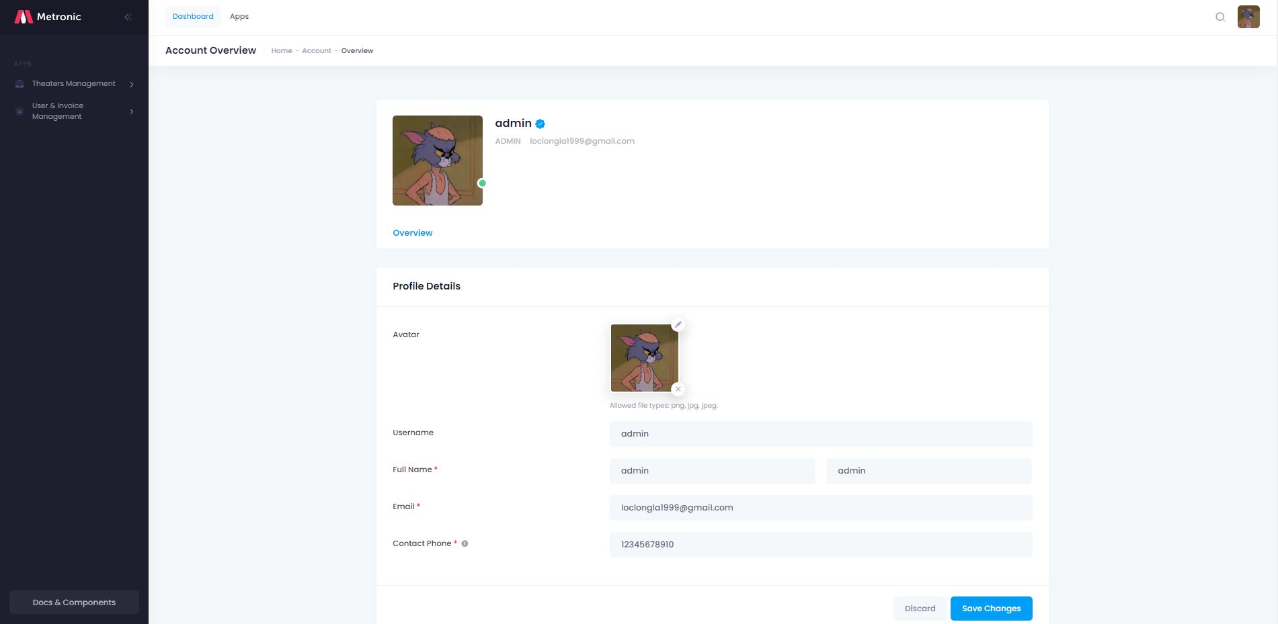

### Admin change password

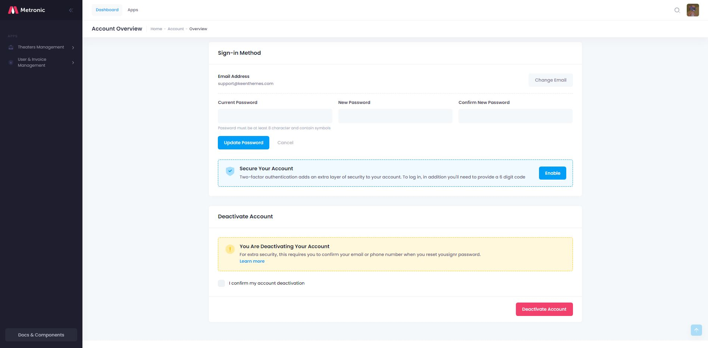

* 1. Movie list

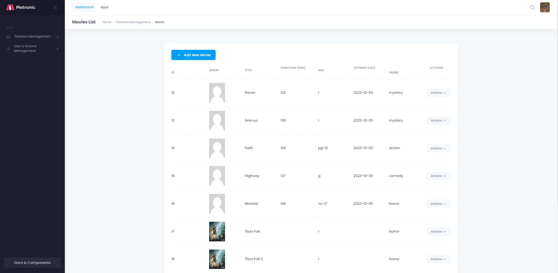

* 1. Movie details

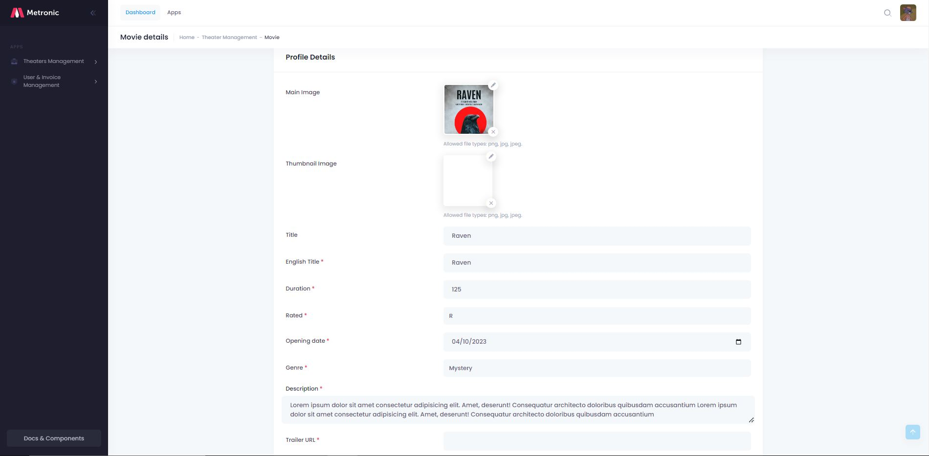

* 1. Director list

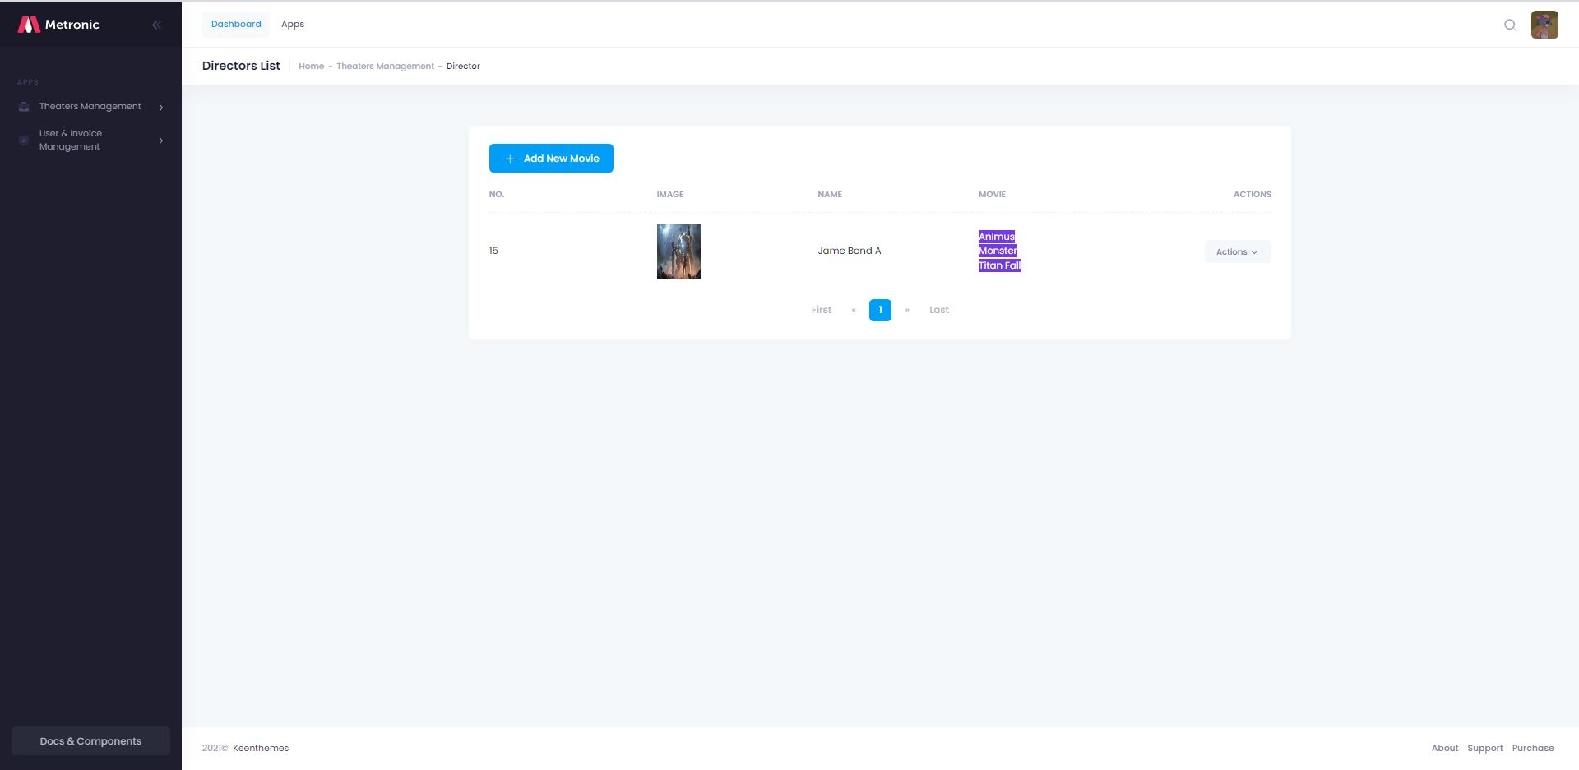

* 1. Director details



* 1. Director list



* 1. Director details



* 1. Director list



* 1. Director details

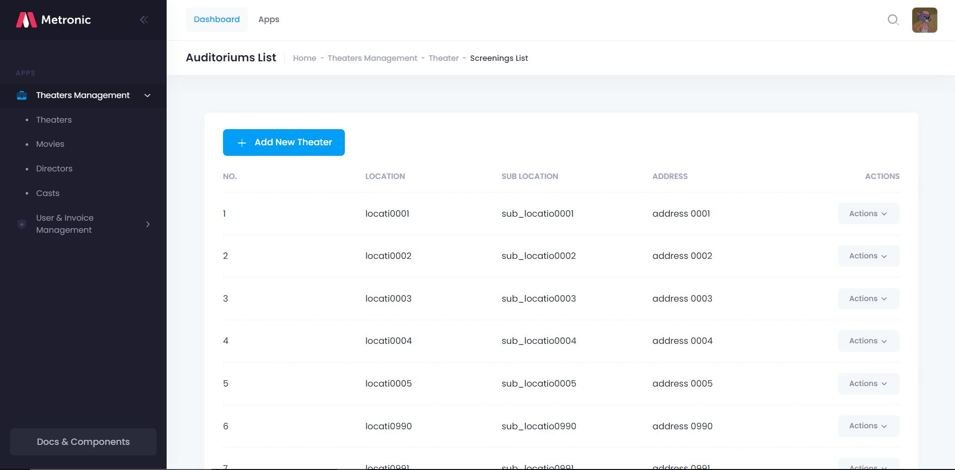

* 1. Theater details

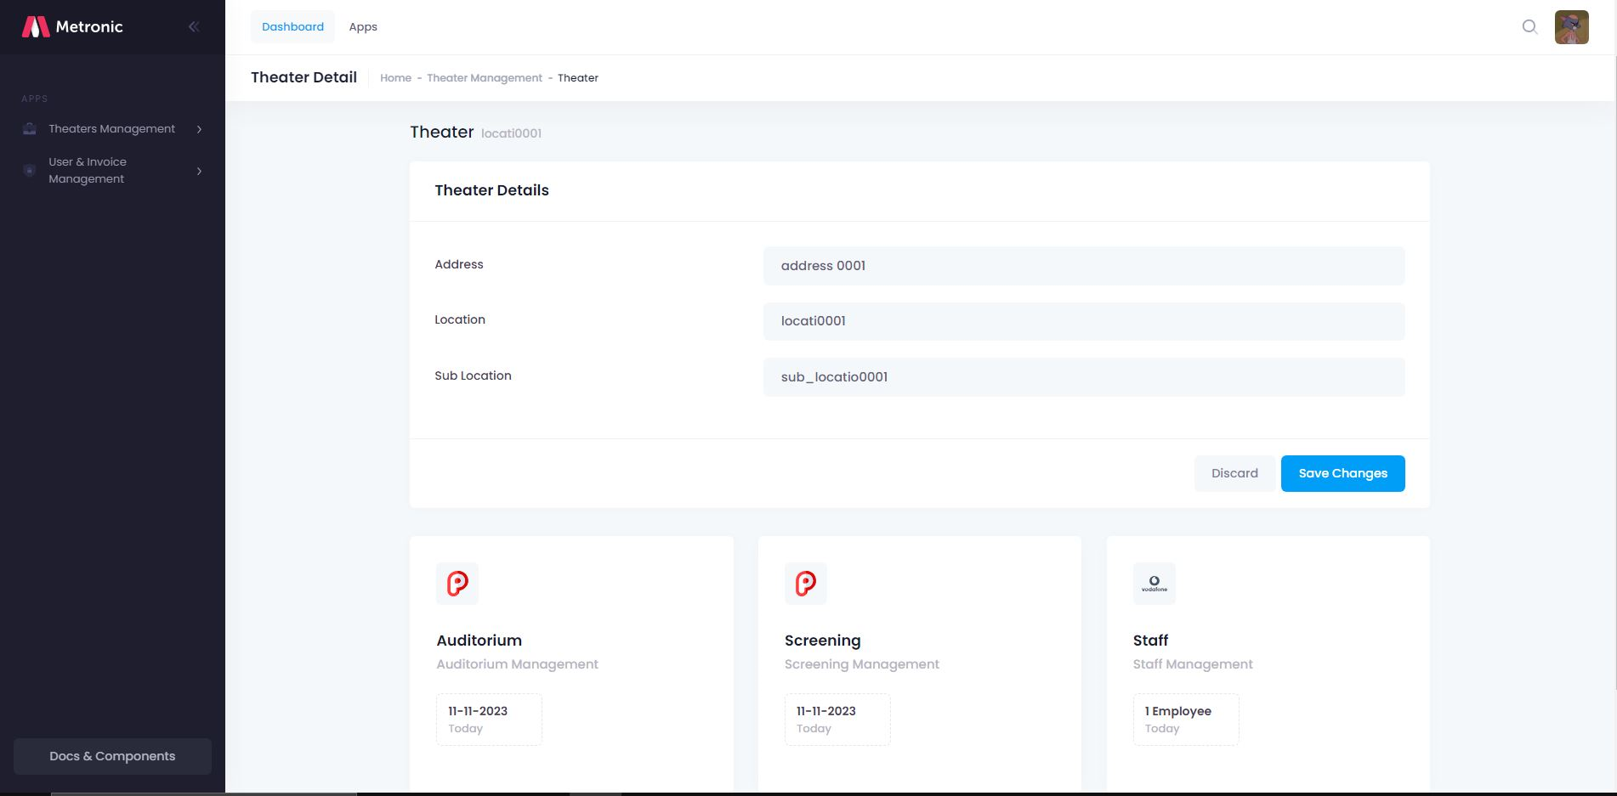

* 1. Screening details

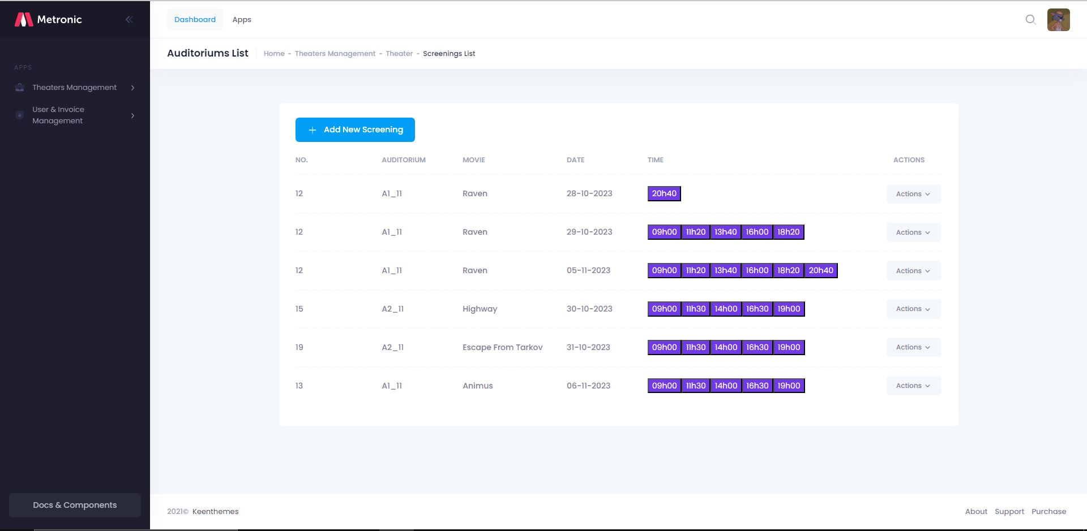

* 1. Screening add

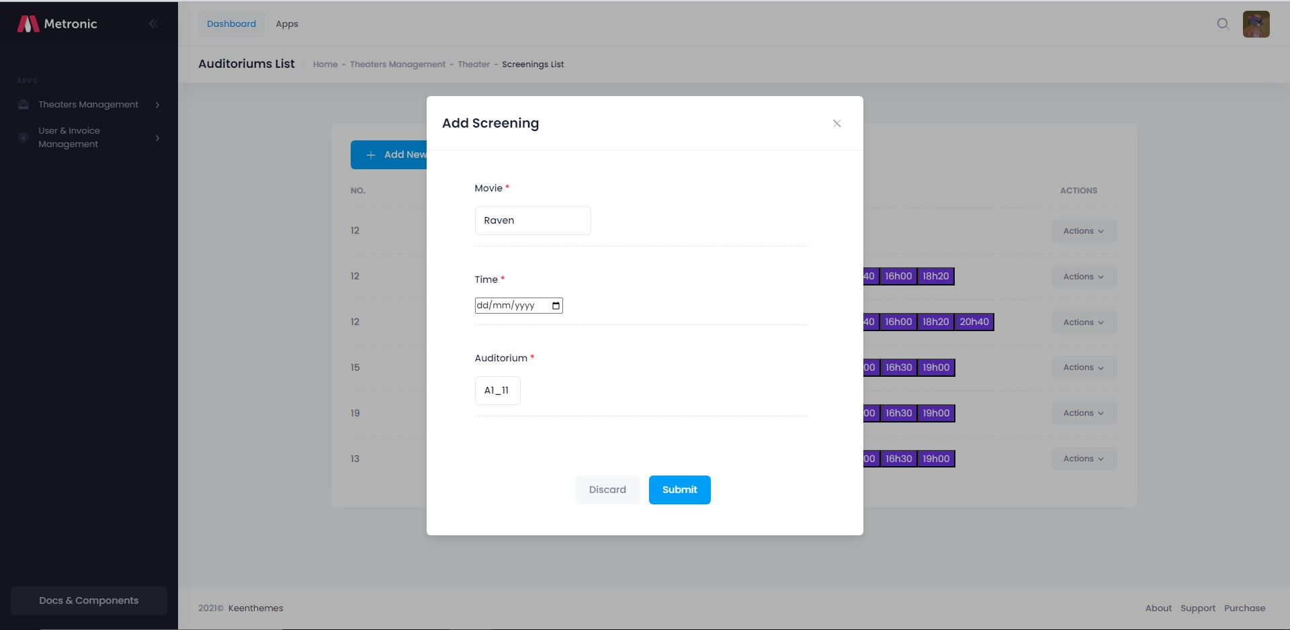

* 1. Invoice list

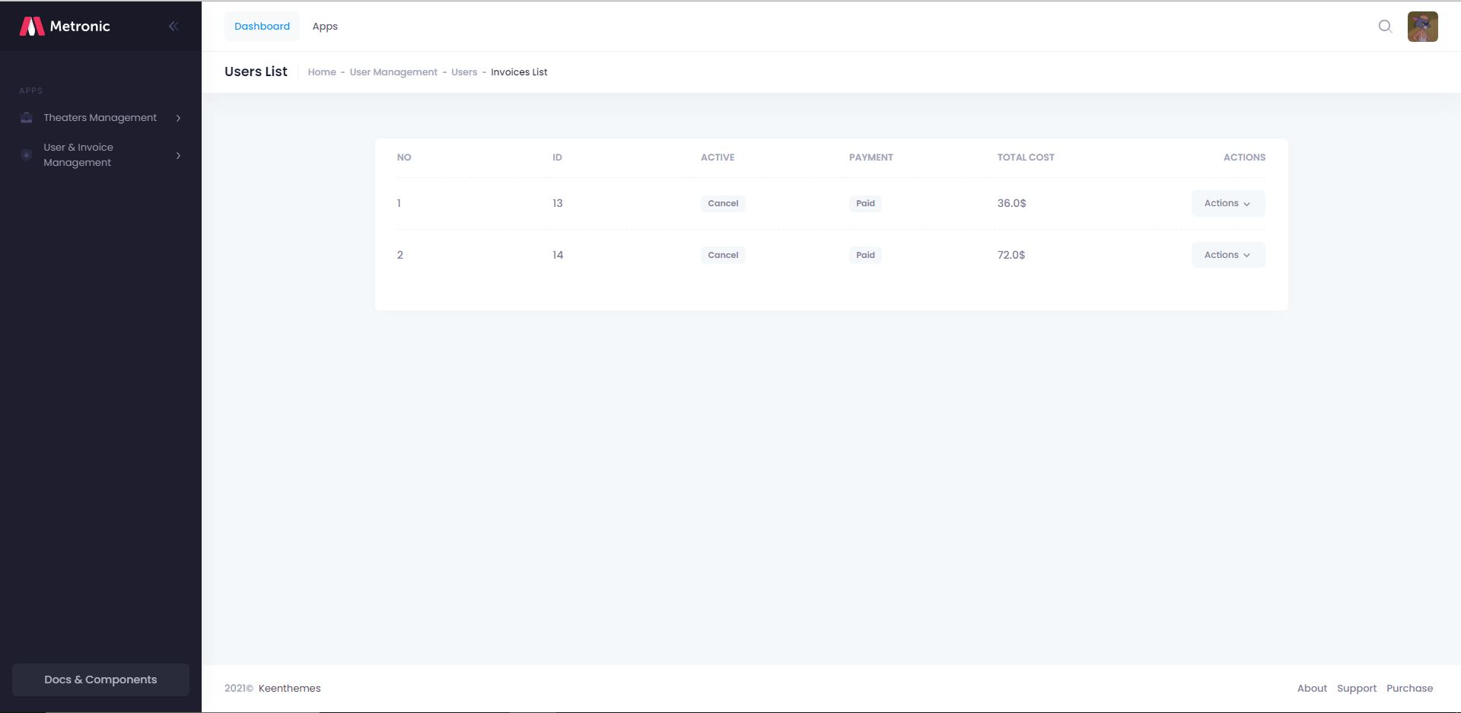

* 1. Invoice details

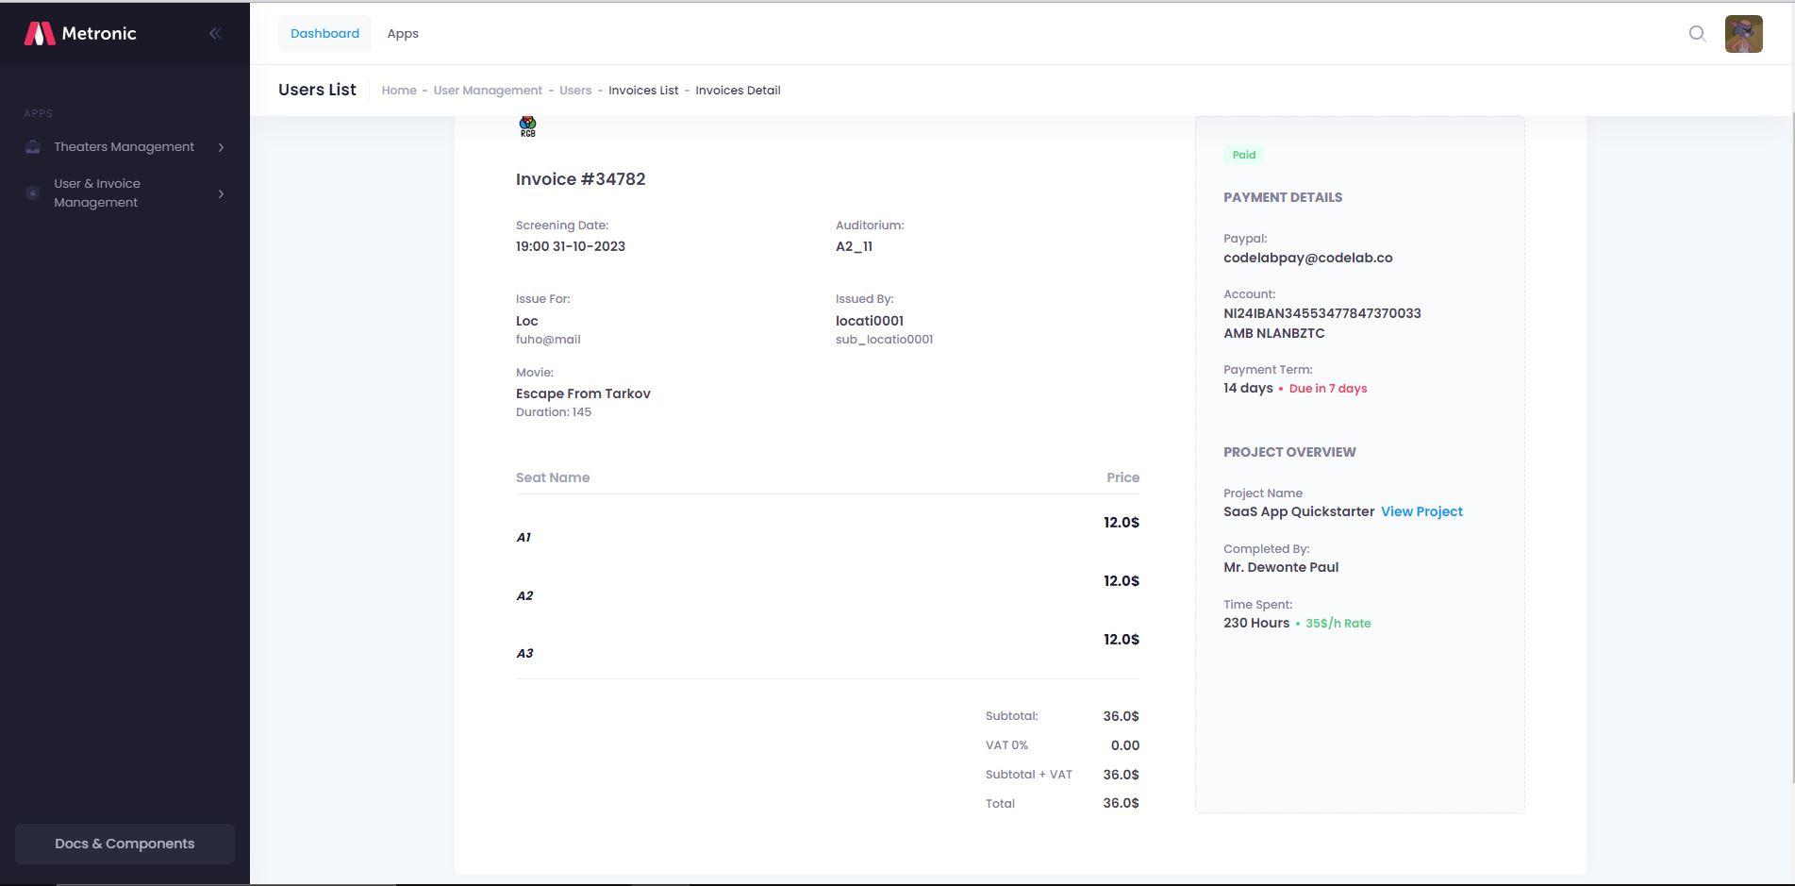

## Web GUI Design

### Home

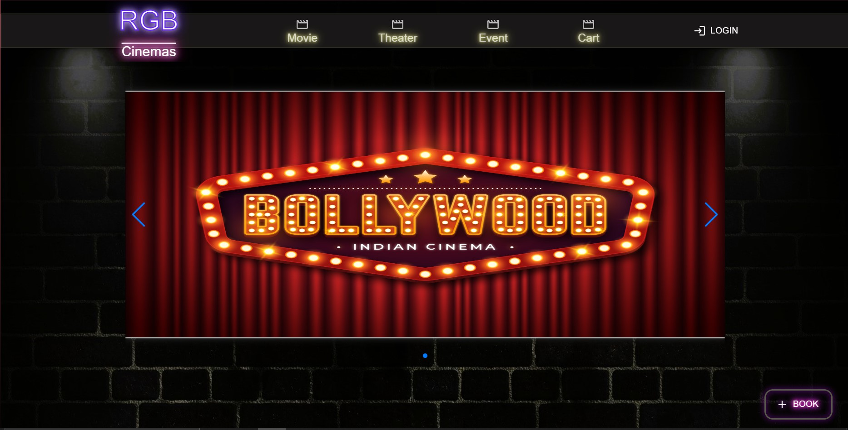

### Login

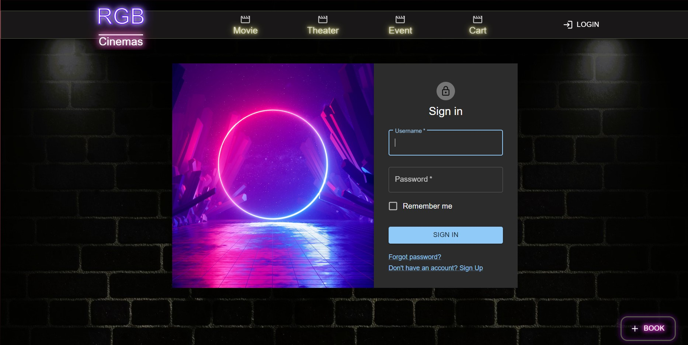

### Register

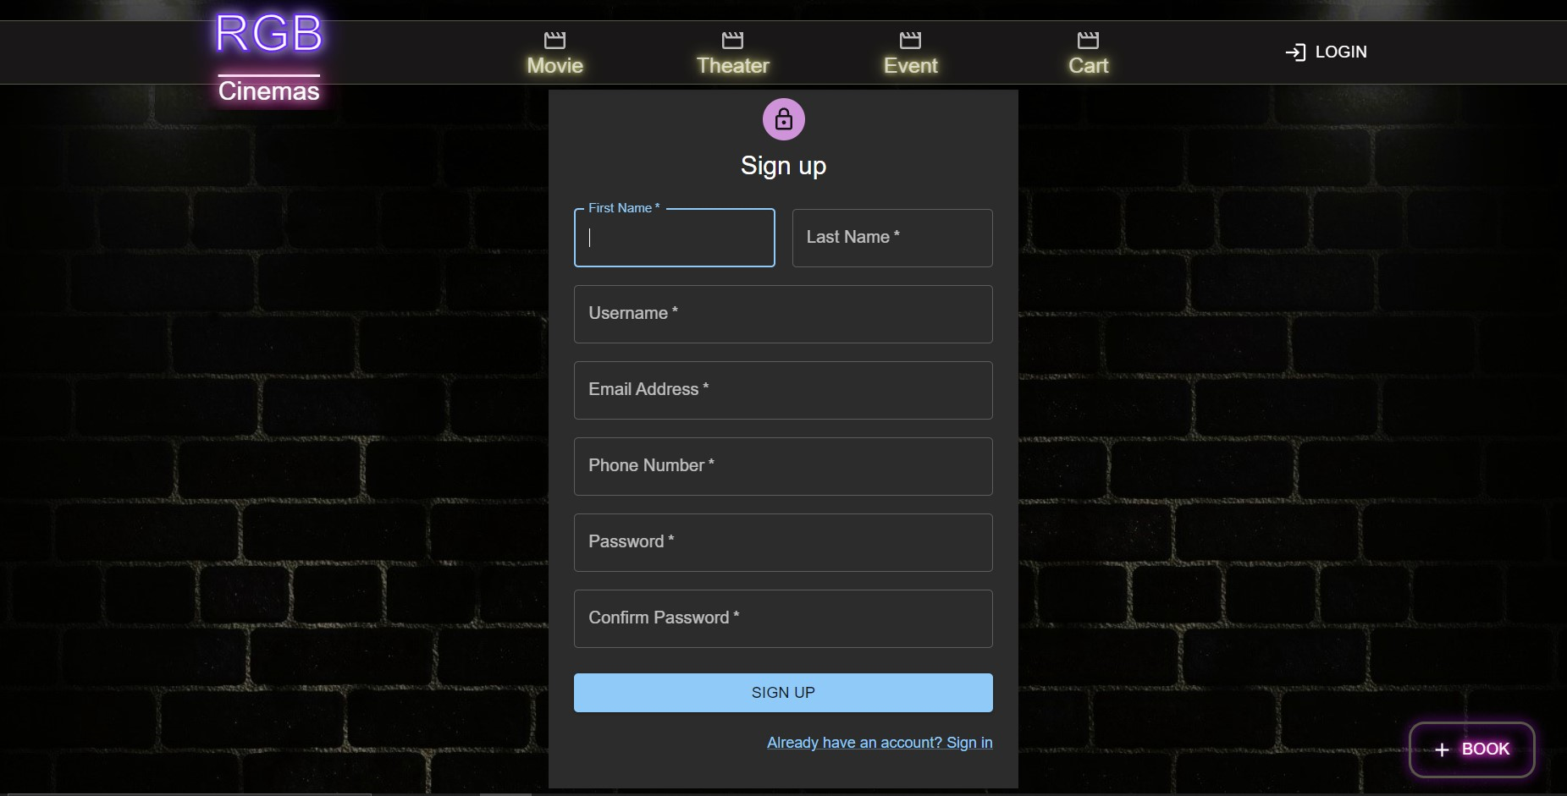

### Movie

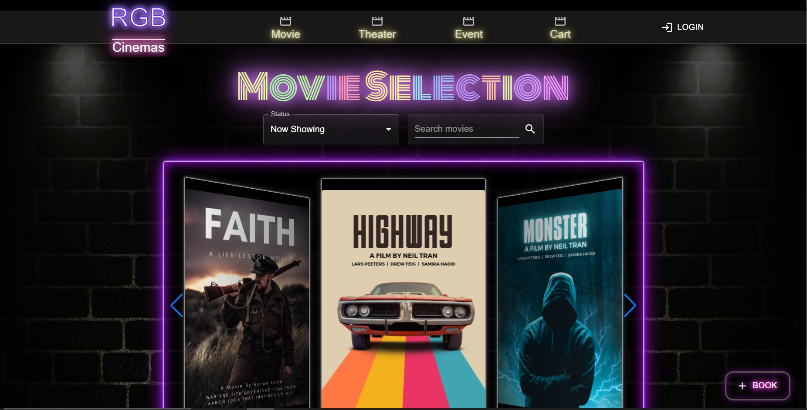

### Edit Profile

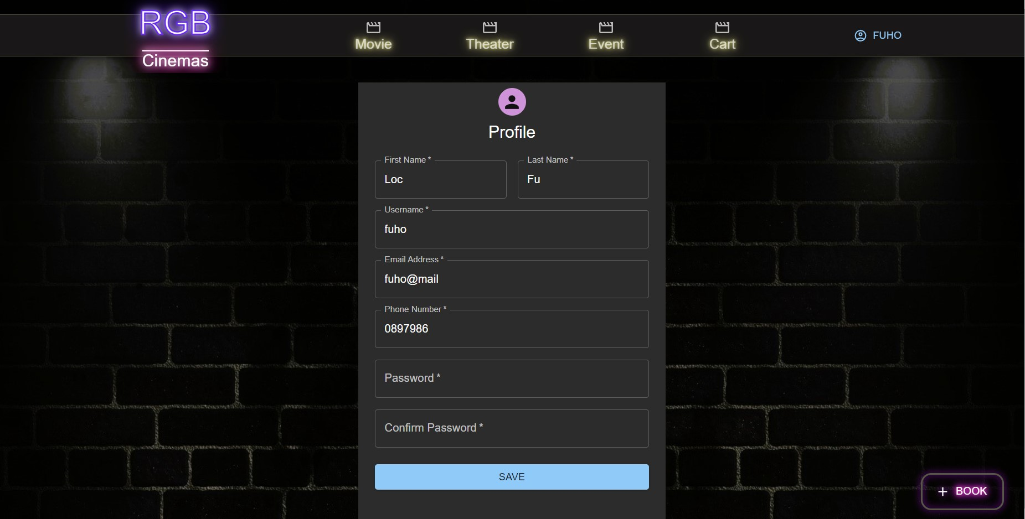

### Booking

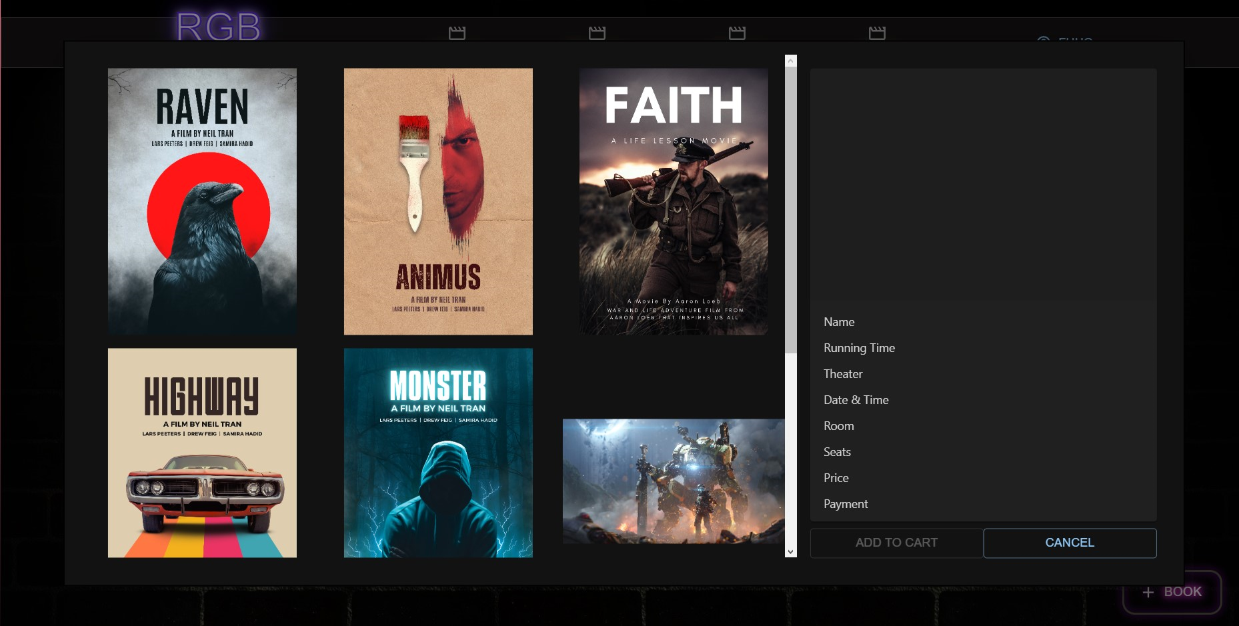

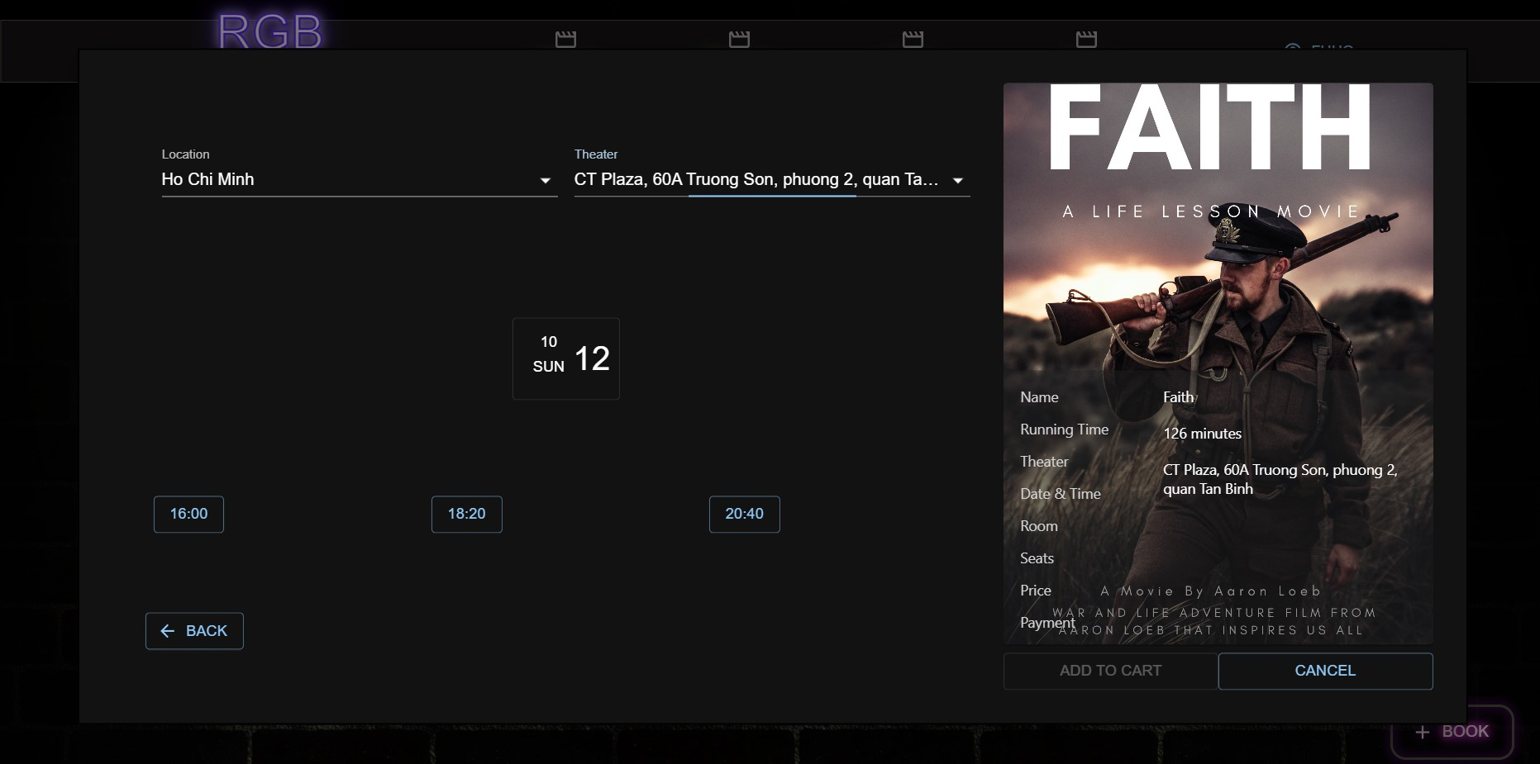

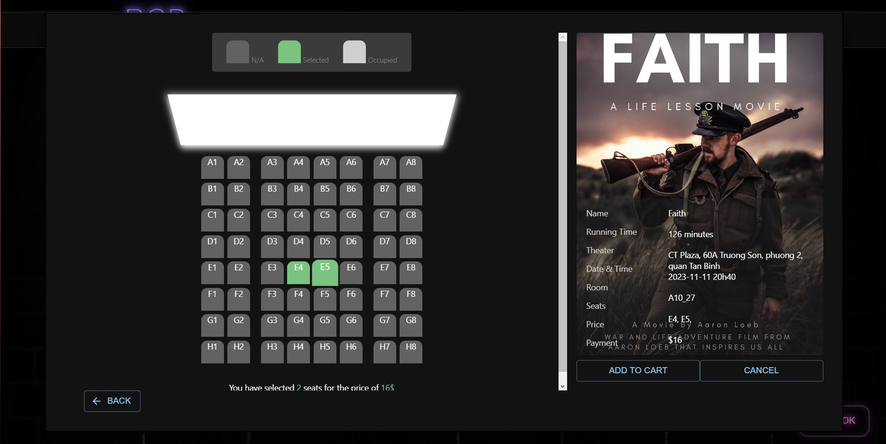

### Cart

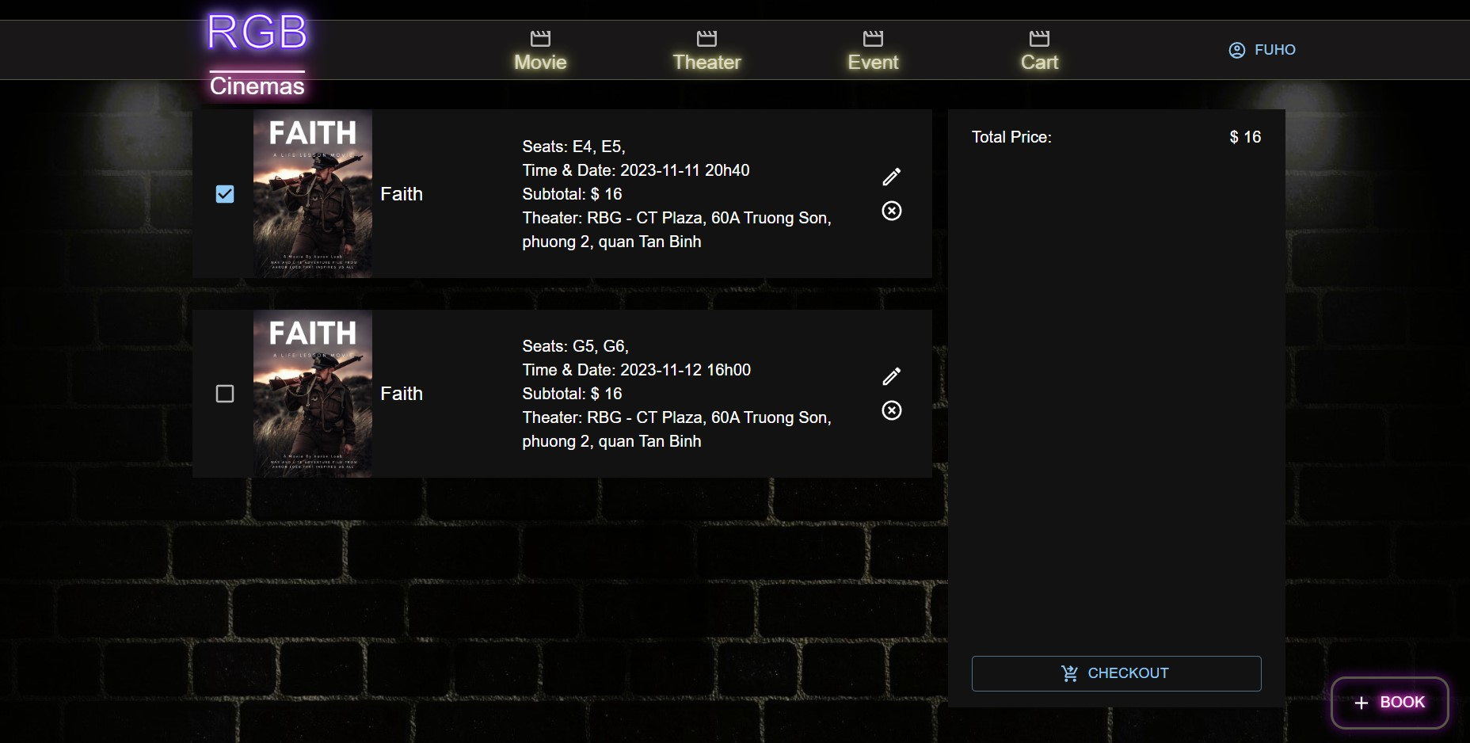

### Checkout

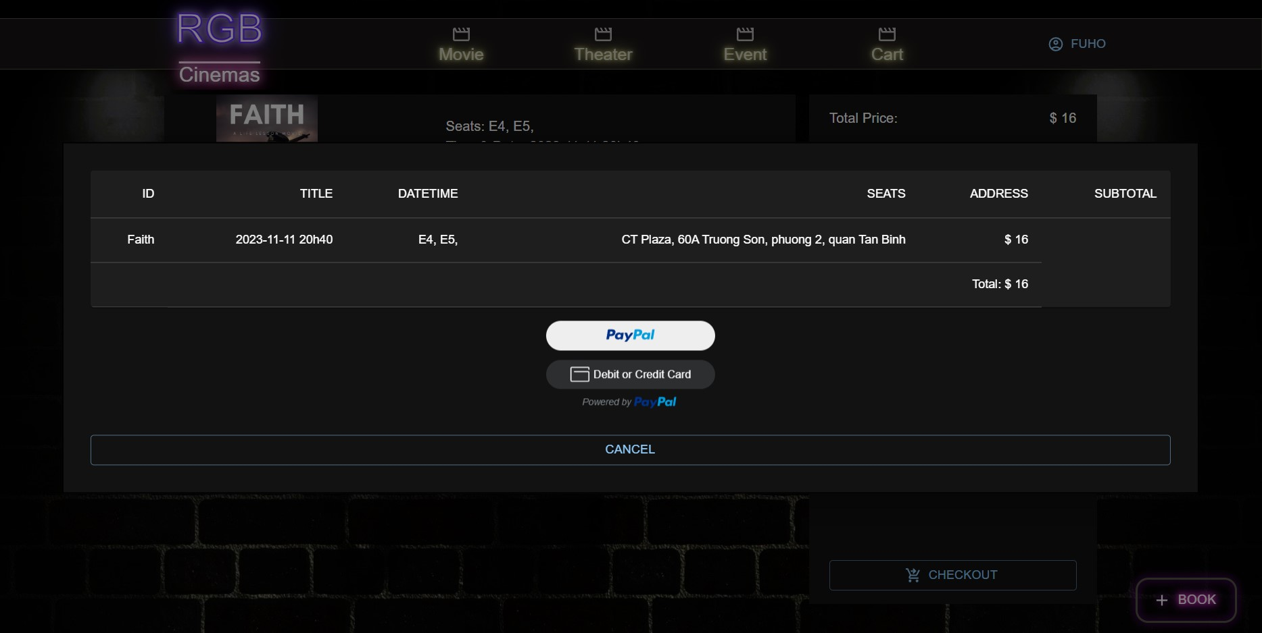

## Mobile GUI Design

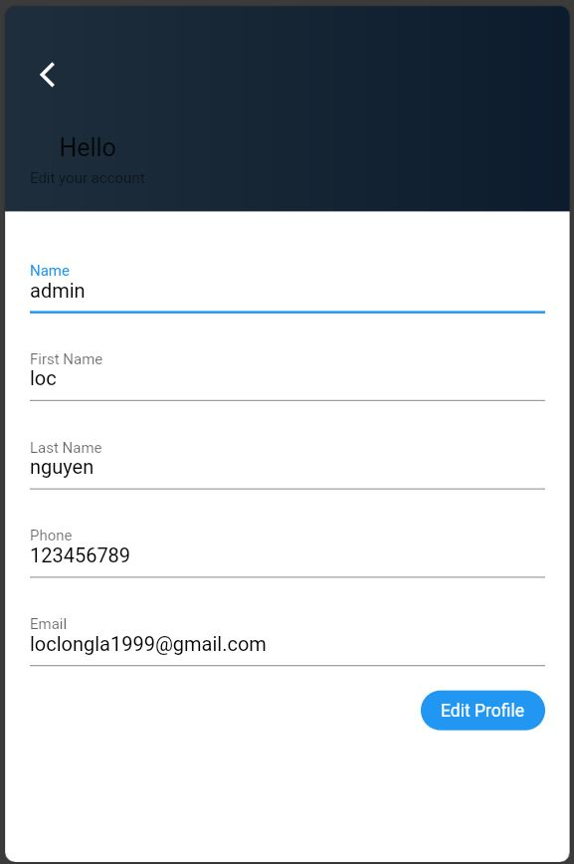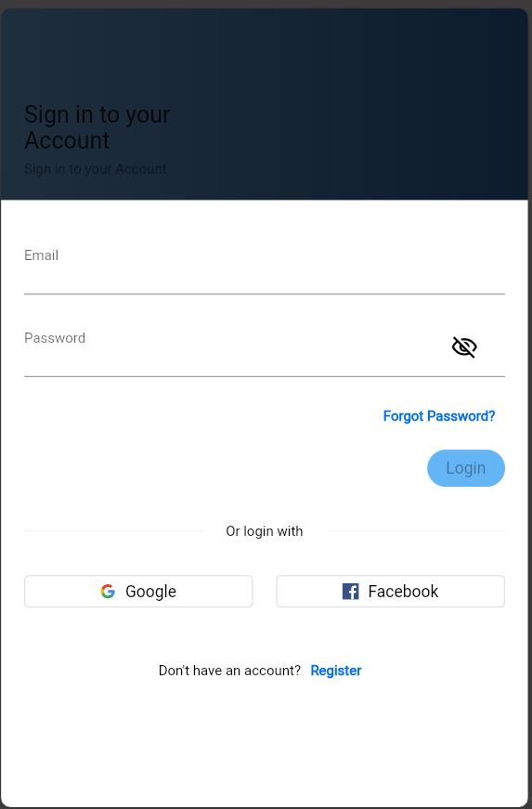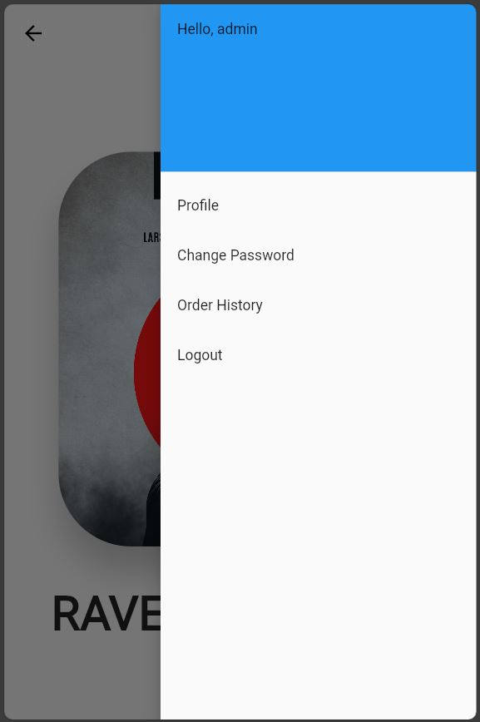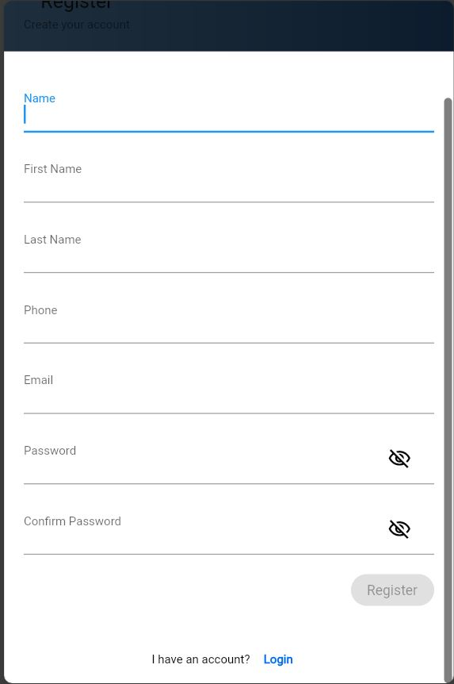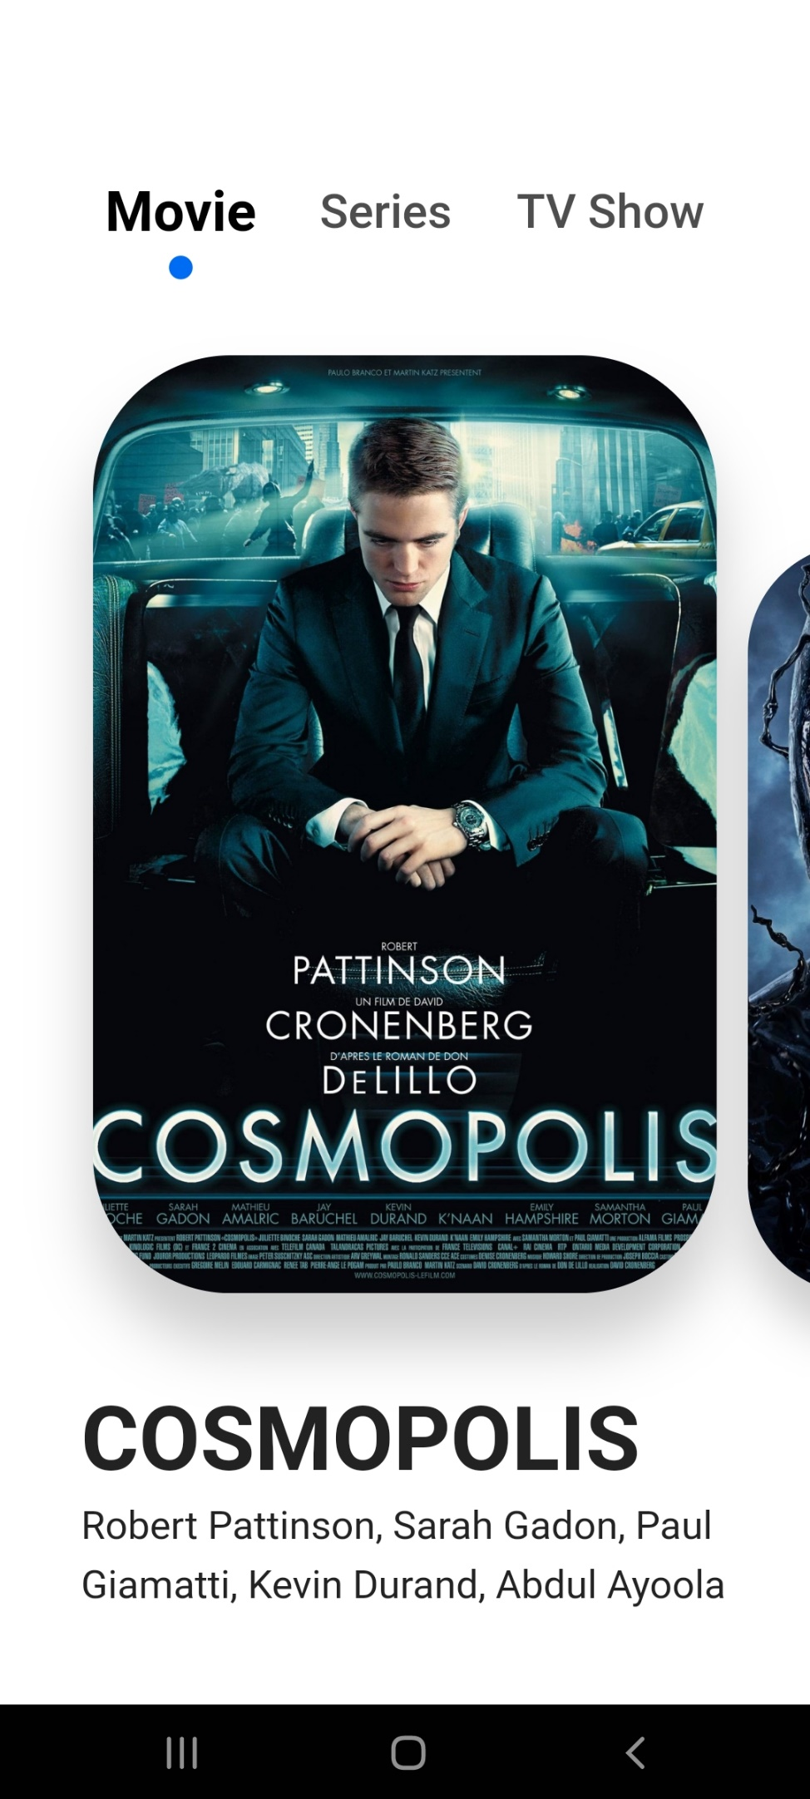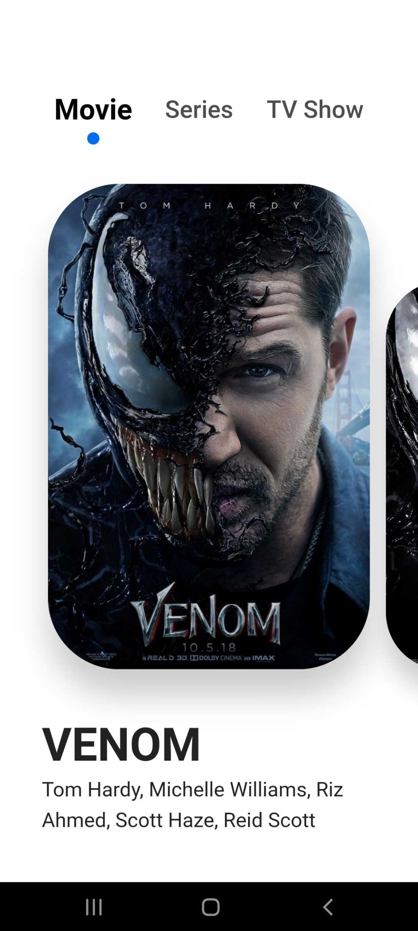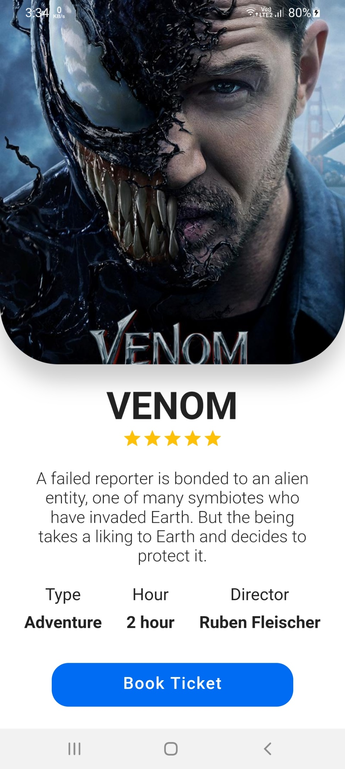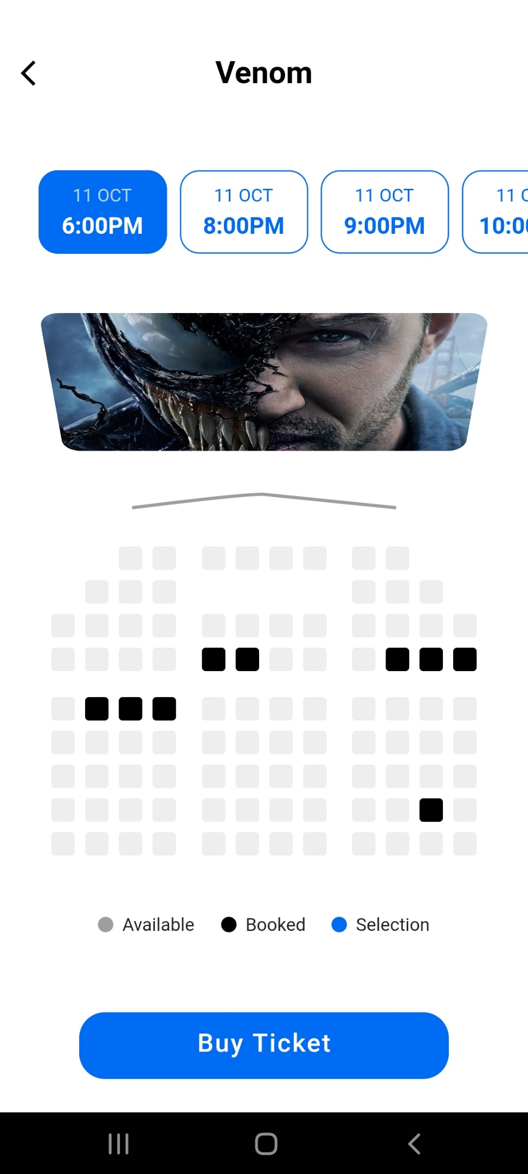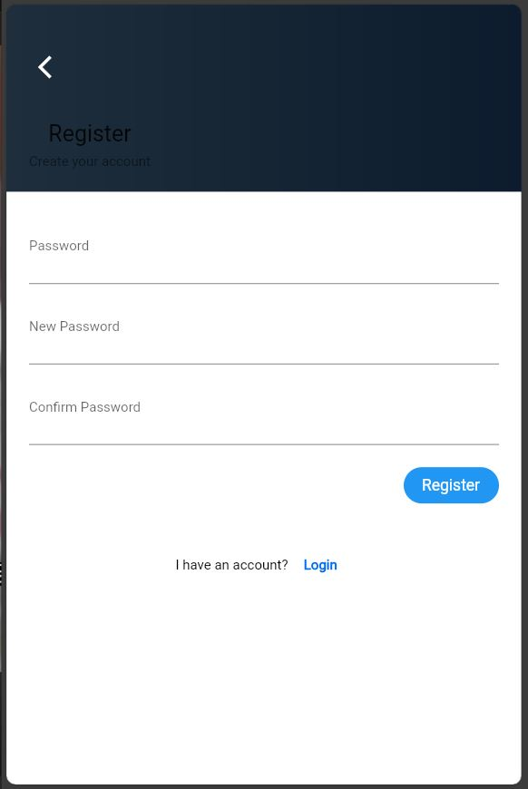

Task Sheet 3

|  |  |  |  |  |  |  |  |  |
| --- | --- | --- | --- | --- | --- | --- | --- | --- |
| **Members Group** | | **Date Preparation of Activity Plan** | | | | | | |
| **No** | **Name** | **Description Task** | **Start Date** | | **End Date** | | **Status** | |
| 1 | Hua Le Quang | Customer Account Management | 18/10/2023 | | 22/11/2023 | | Done | |
| 2 | Hua Le Quang | Customer Booking | | 18/10/2023 | | 22/11/2023 | | Done | |
| 3 | Hua Le Quang | Customer Cart, Payment | | 18/10/2023 | | 22/11/2023 | | Done | |
| 4 | Hua Le Quang | View, Search Movies | | 18/10/2023 | | 22/11/2023 | | Done | |
| 5 | Hua Le Quang | User Forgot Password | | 18/10/2023 | | 22/11/2023 | | Done | |
| 6 | Nguyen Tuan Loc | Admin Account Management | 18/10/2023 | | 22/11/2023 | | Done | |
| 7 | Nguyen Phat Tai | Admin Theater Management | 18/10/2023 | | 22/11/2023 | | Done | |
| 8 | Nguyen Phat Tai | Admin User Management | 18/10/2023 | | 22/11/2023 | | Done | |
| 9 | Nguyen Phat Tai | Admin Movie Management | 18/10/2023 | | 22/11/2023 | | Done | |
| 10 | Nguyen Tuan Loc | Mobile Account Management | 18/10/2023 | | 22/11/2023 | | Done | |
| 11 | Nguyen Tuan Loc | Mobile View Movies | 18/10/2023 | | 22/11/2023 | | Done | |
| 12 | Nguyen Tuan Loc | Mobile Booking | 18/10/2023 | | 22/11/2023 | | Pending | |
| **Teacher** | | | **Team Leader** | | | | | |
| Ngo Van Thuan | | | Nguyen Tuan Loc | | | | | |
|  | | |  | | | | | |